Enterprise Data Architecture Playbook
Sub-Title
Version: X.0
Document History
Delete this table of instructions after finalizing the document
- Ensure all mentioned acronyms are listed and explained in the “Abbreviation” section
- All References in the document need to be put in italics, numbered, and listed in the “Reference” section
- All figures need to be titled
- Note that some sections of the document are mandatory and therefor locked and cannot be changed
Version | Change(s)
1.0 | The first merged version of Enterprise Data Architecture Playbook

Table of Contents
2. Introduction 6
2.1 Purpose 6
2.2 Exceptions 6
2.3 Adaptations 6
2.4 Roles and Responsibilities 6
3. Data Architecture Composition 9
4. Data Landscape & Data Flow Management Guidelines 12
4.1 Data Landscape & Data Flow Management Guidelines 12
4.1.1 Data Landscape & Data Flow Definition and Overview 12
4.1.2 Data Landscape & Data Flow Management Guiding Principles 12
4.1.3 Data Landscape & Data Flow Management Benefits 13
4.1.4 Data Landscape & Data Flow Composition 14
4.1.5 Data Landscape & Data Flow Management: Process 18
5. Data Modeling Management Guidelines 21
5.1 Enterprise Data Model Management Guidelines 21
5.1.1 Enterprise Data Model Definition and Overview 21
5.1.2 Enterprise Data Model Management Guiding Principles 21
5.1.3 Enterprise Data Model Management Benefits 21
5.1.4 Enterprise Data Model Composition 21
5.1.5 Enterprise Data Model Management: Process 21
5.2 Solution Data Model Management Guidelines 21
5.2.1 Solution Data Model Definition and Overview 21
5.2.2 Solution Data Model Management Guiding Principles 21
5.2.3 Solution Data Model Management Benefits 21
5.2.4 Solution Data Model Composition 21
5.2.5 Solution Data Model Management: Process 21
6. Data Harmonization Guidelines 22
6.1 Transformation Technical Rules Guidelines 22
6.1.1 Transformation Technical Rules Definition and Overview 22
6.1.2 Transformation Technical Rules Guiding Principles 22
6.1.3 Transformation Technical Rules Benefits 22
6.1.4 Transformation Technical Rules Composition 22
6.1.5 Transformation Technical Rules: Process 22
6.2 Data Mapping Guidelines 22
6.2.1 Data Mapping Definition and Overview 22
6.2.2 Data Mapping Guiding Principles 22
6.2.3 Data Mapping Benefits 22
6.2.4 Data Mapping Composition 22
6.2.5 Data Mapping: Process 22
7. Metadata Management Guidelines 23
7.1 Metadata Management Overview 23
7.1.1 Metadata Types 23
7.1.2 Metadata Lifecycle Management 25
7.1.3 Metadata Quality Management 27
7.1.4 Metadata Change Request Management 28
7.2 Data Catalog Guidelines 29
7.2.1 Data Catalog Definition and Overview 29
7.2.2 Data Catalog Guiding Principles 30
7.2.3 Data Catalog Benefits 30
7.2.4 Business Glossary Guidelines 31
7.2.4.1 Business Glossary Definition and Overview 31
7.2.4.2 Business Glossary Guiding Principles 31
7.2.4.3 Business Glossary Benefits 31
7.2.4.4 Business Glossary Composition 32
7.2.4.4.1 Business Term 32
7.2.4.4.2 Data Entity 35
7.2.4.4.3 Measures: Metrics, KPIs and Benchmarks 42
7.2.4.4.4 Categories 44
7.2.4.4.5 Business Guidelines 46
7.2.4.4.6 Business Rules 47
7.2.4.5 Business Glossary Establishment 49
7.2.5 Business Assets Guidelines 52
7.2.5.1 Business Assets Definition and Overview 52
7.2.5.2 Business Asset Management Guiding Principles 52
7.2.5.3 Business Assets Composition 52
7.2.5.3.1 Business Process 52
7.2.5.3.2 Authoritative Data Sources 53
7.2.6 Data Dictionary Guidelines 56
7.2.6.1 Data Dictionary Definition and Overview 56
7.2.7 Key Attributes to be Captured 57
7.2.7.1 Data Dictionary Guiding Principles 59
7.2.7.2 Data Dictionary Benefits 59
7.2.7.3 Data Dictionary Composition 59
7.2.7.3.1 Data Asset 59
• Data Privacy 64
• Data Confidentiality 65
• Data Integrity 65
• Publish from GxP Validated Systems 66
7.2.7.4 Data Dictionary: Process 68
7.2.8 Technology Assets Guidelines 68
7.2.8.1 Technology Assets Definition and Overview 68
7.2.8.2 Technology Assets Guiding Principles 68
7.2.8.3 Technology Assets Benefits 68
7.2.8.4 Technology Assets Composition 68
7.2.8.4.1 Data Physical Repositories 68
7.2.8.4.2 Operational Assets 74
7.2.8.5 Technology Assets: Process 75
7.2.9 Linkage between Business Glossary and Data Dictionary 75
7.2.10 Data Lineage Guidelines 76
7.2.10.1 Data Lineage Definition and Overview 76
7.2.10.2 Data Lineage Guiding Principles 77
7.2.10.3 Data Lineage Benefits 77
7.2.10.4 Data Lineage Composition 77
7.2.10.4.1 Business Lineage 77
7.2.10.4.2 Technical Lineage 79
7.2.10.5 Data Lineage: Process 80
8. Definitions 82
9. Abbreviations 83
10. References and Appendices [Edit or delete as needed] 84
10.1 References 84
10.2 Appendices [delete if not used] 84
10.2.1 Appendix A (Name of appendix) 84

Introduction

Purpose
The Enterprise Data Architecture Playbook (DA Playbook) is a tactical and operational document that provides specific guidelines for Novartis Data Architecture function execution at enterprise level and its adoption at Data Domain levels. These guidelines include the detailed instructions on Data Entities identification, Metadata Modeling, Data Modeling, Data Harmonization, applying data classification, etc. As Data Architecture is a part of Data Management, the DA Playbook highlights the points of contact with other DM functions. Thus, the Enterprise DA Playbook describes crucial aspects of the Data Management operating model for Data Architecture function execution in the context of Novartis EDM.
The Enterprise DA Playbook is focusing on Data Architecture capabilities and their implementation via provided Data Architecture Operating Model:
- DA component
- Process description
- Engaged roles & responsibilities.
- Application.
The primary audience for a DA Playbook includes EDOs, Data Architects, Domain Architects, Solution Architects, Data Modelers, Data Stewards who are responsible for Data Architecture design and implementation. Data Architecture Governance should be provided by Enterprise Data Management (EDM) and Enterprise Architecture (EA) representatives to assist the Data Domain team to adopt Data Architecture guidelines described in this document.

Exceptions
The Enterprise DA Playbook does not contain the Data Governance guidelines that should be defined and implemented on top of key Data Architecture processes to ensure that DA processes are built correctly and can operate stably over a long period in alignment with EDM and the organization's strategic goals.
The Enterprise DA Playbook does not contain the Data Quality guidelines that should be defined and implemented around Metadata to ensure that key data items (Data Entity, Data Asset, Data Source, others) are discoverable, understandable, and trustworthy, leading to more informed decision-making and better data-driven outcomes within an organization.

Adaptations
<Do the domains have the authority to make changes to adapt this document? If yes, then state what can be modified for adaptation else explicitly state that adaptations to this document are not permitted>

Roles and Responsibilities
Key Data Architecture Roles and Responsibilities are described in detail in a separate document named as Data Architecture RACI Matrix. The list of key roles and responsibilities is presented in the table below. These roles are used in DA Operating Model.

Group | Role | Responsibilities
EDM | Data Governance Lead | Data Governance Lead (EDM SME) is a senior-level role responsible for managing and representing Novartis Data Management needs and interests to ensure that data is collected, stored, utilized effectively, securely and in compliance with relevant regulations and policies to support the Novartis goals and objectives. Provides support to promote a data-driven culture and ensure effective data governance across Novartis.
EA | Enterprise Architect  (Technology Focus) | Enterprise Architect is a senior-level role responsible for designing and managing the overall architecture of Novartis systems, applications, and technology infrastructure. Enterprise Architect collaborates with business leaders, stakeholders, and IT teams to align the architecture with Novartis business goals and objectives. This role involves strategic planning, technology evaluation, architecture design and governance to ensure efficient and effective use of IT resources. Enterprise Architect facilitates communication and collaboration between different groups and manage risks associated with architectural changes.
EDM | Enterprise Data Architect  (cross-Domain Business & Data focus) | Enterprise Data Architect is a senior-level role responsible for developing and implementing data architecture strategies based on maturity levels of Novartis, data architecture roadmap design, data architecture processes and conceptual data models at enterprise level. Enterprise Data Architect collaborates with business leaders, stakeholders, and IT teams to align data architecture initiatives with business goals, ensuring data consistency and optimizing EDM process at all. Enterprise Data Architect defines data architecture, including data modeling, metadata management principles, guidelines, standards, and best practices.
EDM | Data Modeling Governance Lead | The Data Modeling Governance Lead is responsible for overseeing and managing the enterprise data modeling process in Novartis. This role ensures the integrity, consistency, accuracy of enterprise data models across various data systems, applications by enforcing data modeling standards and best practices. The Data Modeling Governance Lead collaborates with various teams to drive data-driven decision-making and promote a culture of data quality and governance.
DDIT BFF | Domain Architect (Business & Technology Focus) | Enterprise Architect - Domain (a.k.a. Domain Architect) is a role responsible for aligning Novartis’ strategic goals and business objectives with technology solutions within a specific domain. This role combines deep knowledge of business processes, industry trends and technology to design and implement effective and efficient solutions that drive business value.
DDIT BFF | Solution Architect  (Technology Focus) | Solution Architect is responsible for designing and implementing technology solutions that address data-related challenges and meet business requirements. Assesses data requirements, designs end-to-end data solutions, selects appropriate technologies, and ensures data storage, data integrity, security, scalability, performance, etc. Collaborates with cross-functional teams, communicates technical concepts, and contributes to data governance practices.
DDIT BFF | Data Architect | Data Architect is responsible for designing and overseeing the implementation of data-related processes and structures within the Domain. Collaborates with stakeholders to understand business requirements and translates them into efficient data processes and enterprise data models ensuring data integrity, consistency, and usability. Establishes metadata management frameworks to capture and maintain information about data assets, enabling effective data governance and data lineage tracking.
DDIT BFF | Data Modeler | Data Modeler is responsible for creating and maintaining data models that represent the structure and relationships of data within Novartis’ information systems. Gathers data requirements and translates them into conceptual, logical, physical data models. Ensures data integrity and quality by implementing constraints in the models. Works closely with engineering team to optimize data model performance, documents data models including entity-relationship diagrams, business glossary and data dictionary.
Business - EDO | Data Steward | Data Steward is responsible for ensuring the quality, integrity, and compliance of data within domain or business function via monitoring data quality, collecting business and technical metadata, resolving data issues, enforcing data privacy and security classifications and measures. Collaborates with stakeholders, maintains data documentation, and promotes data management best practices.
Business - EDO | Data Owner | Data Owner is a senior-level business representative who has authority to make decisions and drive data management strategy within a specific data domain. Provided cross functional and strategic direction for the business and ensures domain data remains of high quality throughout its lifecycle. The role is accountable for the execution of Novartis’ ambition to turn data into strategic asset to drive actionable insights. Represents data domain within the data council.

Data Architecture Composition
Data Architecture is a fundamental and major Data Management Capability within organization. Data Architecture is the strategy and execution of how data is identified, defined, described, designed, harmonized across organization to support the business objectives. Data Architecture refers to the structured design of an organization's data entities and data assets, encompassing data models, metadata models, data flow, data mappings, and transformation rules.
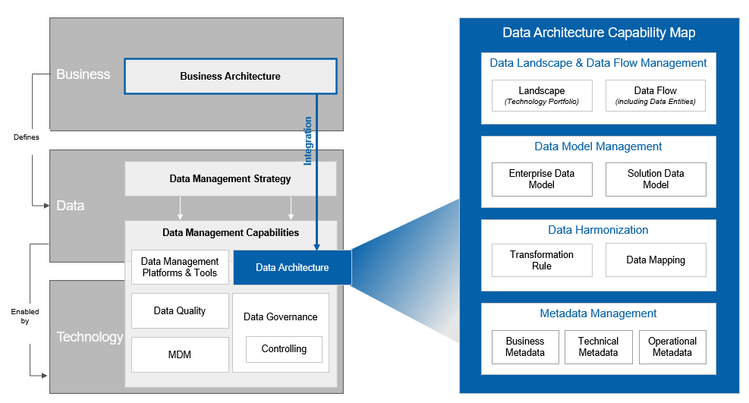
Figure #: Data Architecture Capability in Enterprise Data Management

The Enterprise Data Architecture Playbook describes the guidelines to increase maturity of key DA sub-capabilities and components:
- Data Landscape refers to the comprehensive view of an organization's data environment, including sources, physical repositories, processing, governance, utilization. A well-defined data landscape helps organizations gain insights from their data assets, improve data governance, and make informed strategic decisions.
- Data Flow Management, on the other hand, focuses specifically on the design and management of data movement and transformation processes to ensure the effective flow of data through an organization’s Data Landscape. Effective data flow management streamlines data processes, ensuring timely and accurate data delivery, enhancing operational efficiency, and supporting agile decision-making.
- A Data Model is a conceptual or visual representation of how data is organized, structured, and related within a database or an information system. It defines the rules and relationships governing the storage, retrieval, and manipulation of data in a structured format. Data Modeling provides organizations with a structured framework for designing and organizing their data, leading to improved data quality, consistency, and understanding. It enhances the efficiency of database design and query performance, reducing processing times and costs. Additionally, data modeling supports effective communication, collaboration, and decision-making, aligning data resources with business objectives.
- The primary goal of Data Harmonization is to create a unified and consistent view of data from multiple sources within an organization or across different organizations. Data harmonization aims to bring together diverse data sets which may originate from various systems, formats, or locations, and make them compatible and coherent. Data Harmonization achieved through data pipelines, transformation rules, data standards, normalization, and data mappings, streamlines the integration of diverse data sources, improving data quality and facilitating more accurate and efficient decision-making. This harmonized data ecosystem reduces redundancy, aligns data with organizational standards, and enhances data consistency, ultimately driving better insights and operational efficiency.
- Metadata refers to structured information that provides context, description, and details about data, making it easier to manage, discover, use, and understand. Metadata Management enhances data discoverability and understanding by providing context and descriptions about data assets, making it easier for users to find and utilize relevant information. It supports effective data governance by documenting data lineage, quality, and compliance with regulatory requirements, ensuring data is managed and used in a controlled and compliant manner. Metadata Management fosters collaboration and knowledge sharing among data stakeholders improving communication and alignment of data strategies with organizational goals.
Data Architecture serves as an enabler for Business Architecture, ensuring that the organization's data assets are structured, designed, managed, and utilized in a way that supports the business's overall goals and objectives. So that, an initial stage of Data Architecture activities in organization’s Data Lifecycle is related to conceptual design – ability to translate the business use cases to “data Language”. The Business Terms and various business assets (business process, data source, business organization, etc.) are key components of this kind of translation. The Business Term in most of cases is a conceptual representation of a Data Entity.
A Data Entity is a specific, discrete piece of data that represents a single, unique concept, object, or thing within a Data Management system. Data Entities are fundamental building blocks in data modeling, and they help organize and structure data in a way that is meaningful and useful for an organization. Data Entities are typically associated with attributes that describe the characteristics or properties of the Data Entity. Data Entities are used to structure and describe the data within Data Assets.
A Data Asset is a broader concept that refers to a collection or set of data that is valuable and useful to an organization. Data Assets are often organized around a particular theme or subject area. A Data Asset may consist of multiple data entities, each representing a different aspect or piece of information related to the asset's theme. For instance, in a "Sales Data Asset," you may find the data entities like "Product," "Customer," "Order," and "Inventory," each contributing to the overall understanding and analysis of sales-related information.
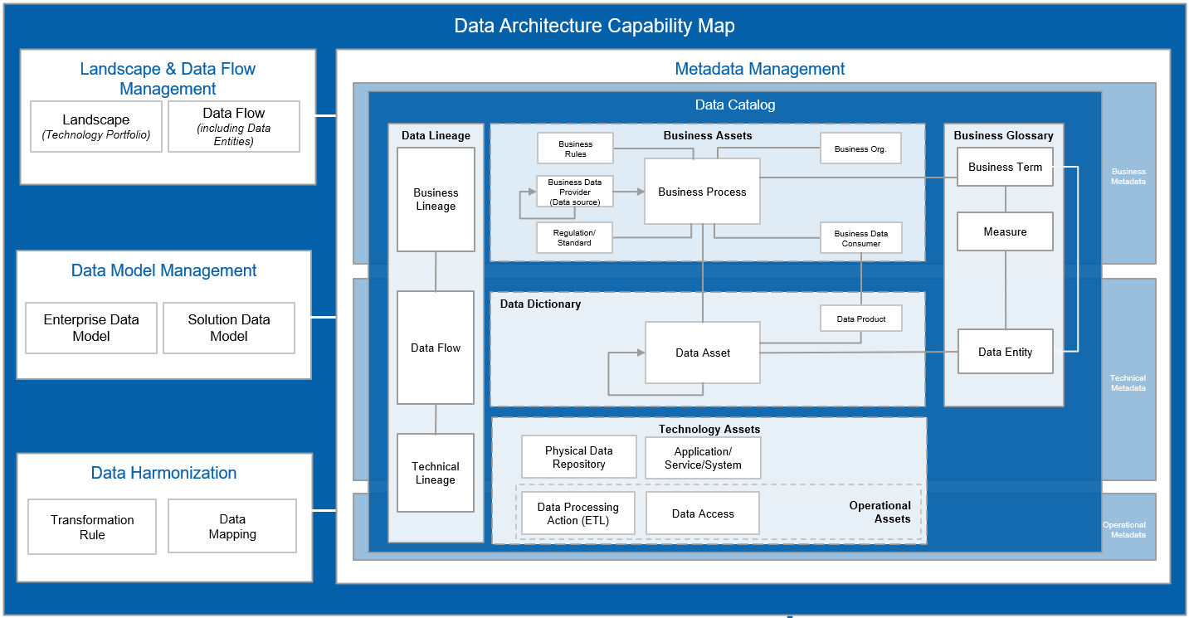
Figure #: Data Architecture Capability Map

Data Landscape & Data Flow Management Guidelines

Data Landscape & Data Flow Management Guidelines

Data Landscape & Data Flow Definition and Overview
The Data Landscape is a comprehensive and holistic view of all data-related aspects within an organization or specific context. It encompasses the identification of data sources and consumer applications, data types and classification, Data Flows, storage, processing methods (manual, automated, semi-automated), interactions. Understanding the data landscape is crucial for effective Data Management, Data Governance, and informed decision-making. The Data Landscape has a broad scope in comparison to Data Flow.
The Data Landscape is not a static representation of a current or desired future state. It is a dynamic model that can be updated and maintained. It can be used to assess various changes in use cases.
Data Flow represents the movement or transfer of data from one location or data entity to another within a system or organization. It illustrates how data is transmitted, processed, transformed, and consumed. Data flows can be visualized through diagrams, showing the path and transformations data undergoes as it travels through an organization's processes and systems. Data flows can be visualized through Data Flow Diagrams, which provide a clear and concise representation of how data moves through an organization, illustrating data sources, transformations, and destinations. These visualizations aid in communication and analysis of data processes.
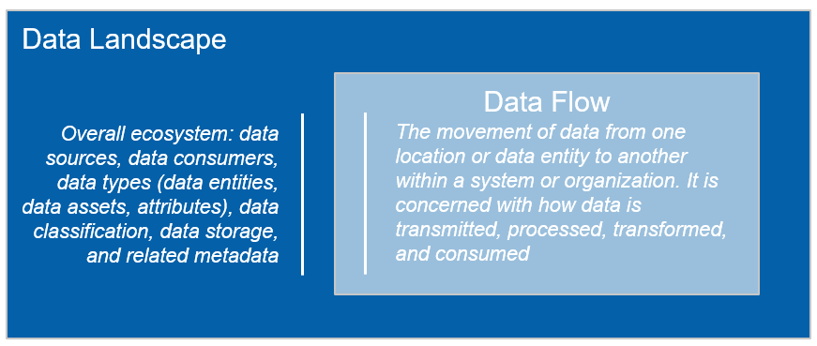
Figure #: Data Landscape and Data Flow definitions
The Data Landscape provides a holistic view of the entire data ecosystem, while Data Flow focuses on the movement and transformation of data within specific data pathways or processes. Both concepts are valuable for effective data management and analysis.

Data Landscape & Data Flow Management Guiding Principles
The Data Landscape & Data Flow guiding principles may not have precise boundaries, but they should guide the creation of any Data Landscape & Data Flow model. Adhering to these principles promotes clarity, effectiveness, and practicality in representing the data landscape, ultimately supporting better decision-making and planning:
- Simplicity over Complexity: Create a model that strikes a balance between detail and complexity. Adding excessive detail can make the model convoluted and less usable. While the threshold for "too much detail" may vary, it's essential to keep the model straightforward, especially in its early stages, to avoid hindering the data landscape creation process.
- Self-explanatory: The data landscape model should aim to be as self-explanatory as possible. It should be easily comprehensible, requiring minimal additional knowledge or explanation to understand its content and purpose.
- Clear Representation: The model's meaning should be immediately evident, without the need for lengthy explanations. Time spent clarifying how to interpret the model is better spent using it for planning and decision-making. The model can incorporate features for information filtering to manage complexity effectively.
- Consistency: Maintain consistency in how information is represented across all instances and types of model presentations. A standardized approach ensures clarity and coherence in understanding the data landscape.
- Utility Focus: Evaluate the model's usability by its practicality and usage. The model should serve as a tool to enhance understanding, generate insights, support planning, and aid in problem-solving and decision-making. It should have a forward-looking perspective, helping to define the future data landscape and resolve issues effectively.
- Relevance: The model should contain only what is pertinent to its intended purpose (Data Landscape & Data Flow Detalization Types). Avoid including irrelevant or extraneous details that do not contribute to the model's value or utility. Documenting the existing data entity landscape can be beneficial for identifying gaps that need attention.
The Data Landscape & Data Flow guiding principles are linked to Data Architecture principles:
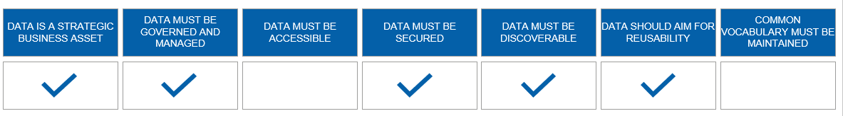
Figure #: Data Architecture principles coverage by Data Landscape and Data Flow

Data Landscape & Data Flow Management Benefits
The Data Landscape Management benefits are:
- Informed Decision-Making: A well-managed Data Landscape provides organizations with a comprehensive view of their data assets, including sources, formats, and relationships. This knowledge empowers decision-makers to make informed choices, backed by accurate and relevant data.
- Data Governance and Compliance: Data Landscape management establishes a foundation for robust data governance. It allows organizations to implement policies, controls, and security measures to ensure data compliance with regulations and industry-specific standards.
- Optimized Data Processes: Understanding the Data Landscape helps organizations streamline data processes. By identifying data redundancies, inefficiencies, and bottlenecks, they can optimize data workflows, leading to improved efficiency and reduced operational costs.
- Enhanced Data Quality: Data Quality is vital for reliable decision-making. Data Landscape Management includes mechanisms for data validation, cleansing, and standardization, which ensure that data remains accurate, consistent, and trustworthy.
- Support for Analytics: A well-structured Data Landscape supports the integration of business intelligence and analytics tools. This enables organizations to extract valuable insights from their data, fostering data-driven strategies and a competitive edge.
The Data Flow Management benefits are:
- Efficient Data Processing: Data Flows represent the movement and transformation of data within an organization's systems. Efficient Data Flow management ensures that data is processed in a timely manner, supporting real-time decision-making and operational efficiency.
- Troubleshooting and Issue Resolution: Data Flow diagrams enable organizations to visualize data movement. When issues arise, these diagrams help pinpoint bottlenecks and errors in data processing, facilitating quicker troubleshooting and problem resolution.
- Data Integration: Effective Data Flow Management ensures seamless data integration across systems and departments. This promotes collaboration, as teams can access and share data more easily, breaking down data silos.
- Data Accuracy and Timeliness: Data Flow Management enhances data accuracy and timeliness. It ensures that data is delivered to its destination in the right format and within specified timeframes, reducing the risk of outdated or erroneous information.
- Cost Savings: By optimizing Data Flows, organizations can reduce data processing costs. This includes minimizing resource usage, optimizing infrastructure, and avoiding unnecessary data duplication.

Data Landscape & Data Flow Composition
To design the Data Landscape and Data Flow diagram the primary landscape components are required:
- Data Source Name (data originator): application where data has been originated.
- Application, System, Service (consumer): application, system or service that consume data.
- Key Data Entity: conceptual data item used in Data Architecture.
- Data Asset: collection of data entities.
- Data Flow: the movement of data from one application/system/service to another or between them.
The secondary landscape components are used to add more context to Data Landscape & Data Flow Model and make the diagram more understandable and readable. Secondary landscape components include but not limited to:
- Business Context: Business Term, Business Process, Business Stakeholders.
- Organizational Context: organizational structure (Enterprise, Domain, sub-Domain, Subject Area, etc.).
- Data Context: data entity attributes, Data Product, Data Security.
- Technology Context: environment types (dev, qa, prod), technologies.

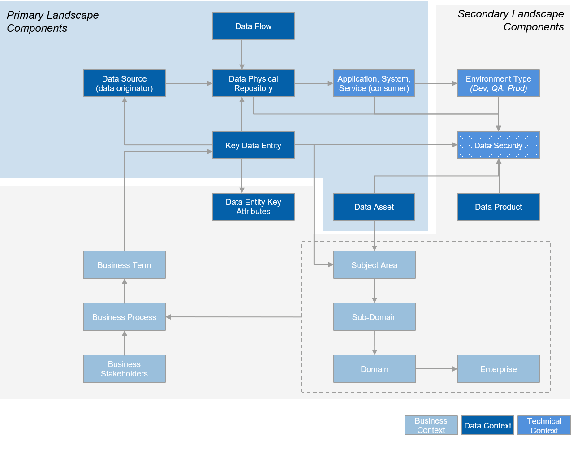
Figure #: Data Landscape Model

The Data Landscape Model needs to be sufficiently flexible to include different levels of details. Depending on demand complexity the Data Landscape & Data Flow diagram can incorporate three dimensions:
- Data Landscape & Data Flow composition: combination of primary and secondary components described above.
- Data Landscape detailed Types:
  - Type 1 – Landscape Type: Foundational Data Landscape & Data Flow components: Applications and Data Flow between them.
  - Type 2 – System Type: Data input/output per a System/Application.
  - Type 3 – Data Entity/Data Asset Type: Data Entity/Data Asset flow across systems/applications where data was originated and consumed.
- Organizational Level: Enterprise, Domain, sub-Domain, Country/Region organizational structure.
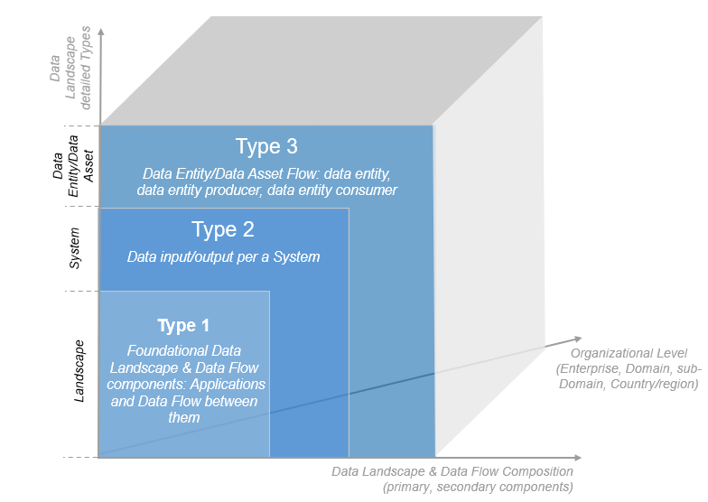
Figure #: Data Landscape & Data Flow Model Detailed Types

Examples of Data Landscape & Data Flow Models various types:
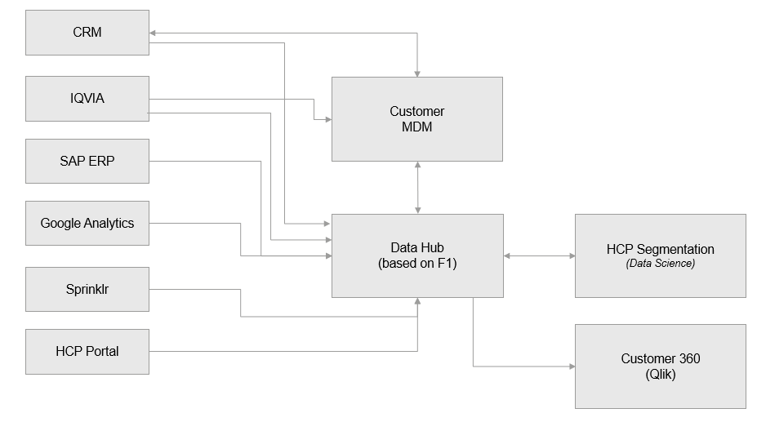
Figure #: Data Landscape & Data Flow Model: Type 1 – Landscape Type

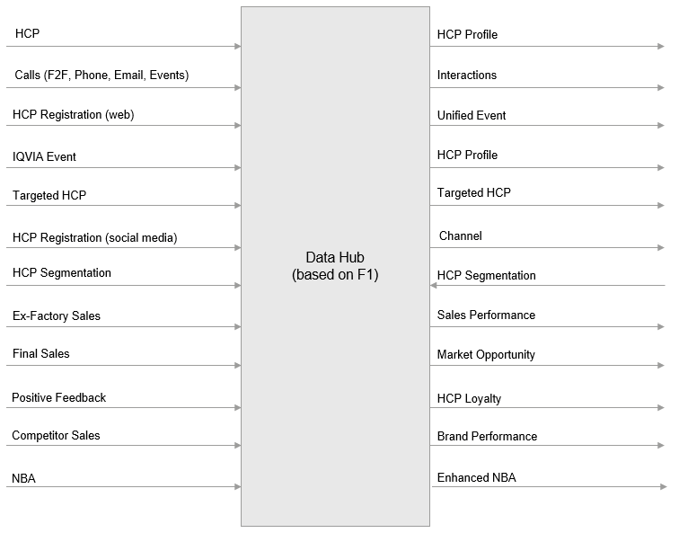
Figure #: Data Landscape & Data Flow Model: Type 2 – System Type

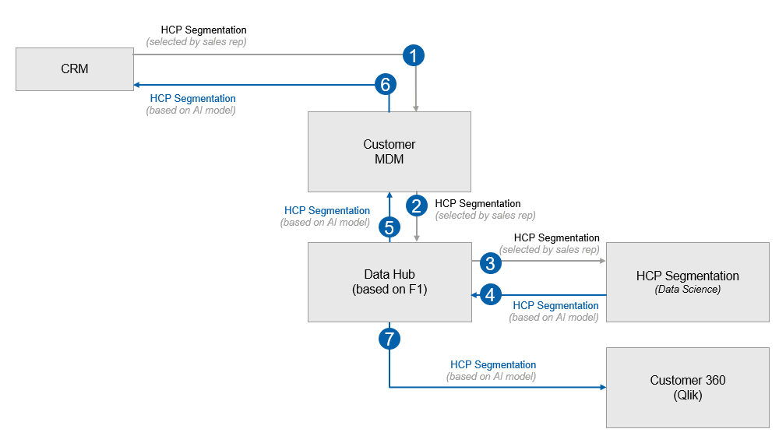
Figure #: Data Landscape & Data Flow Model: Type 2 – Data Entity/Data Asset Level

Data Landscape & Data Flow Management: Process

A Data Landscape & Data Flow Management Framework is a structured approach that outlines the processes, practices, and tools required to effectively manage landscape and data flow across Data Domains. The following steps represent the framework:
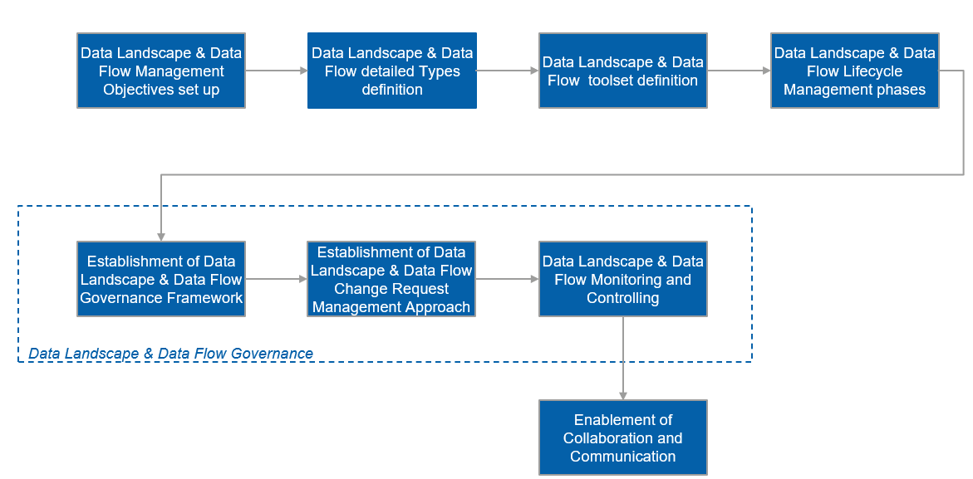
Figure #: Data Landscape & Data Flow Model Management Framework (Process)

The Data Landscape & Data Flow Lifecycle Management refers to the systematic management of Data Landscape & Data Flow Model throughout its entire existence, from its creation or capture to its archiving or retirement. This lifecycle management ensures that Data Landscape & Data Flow Model remains accurate, relevant, and useful for various data management and governance purposes. The Data Landscape & Data Flow Lifecycle consists of the following phases:
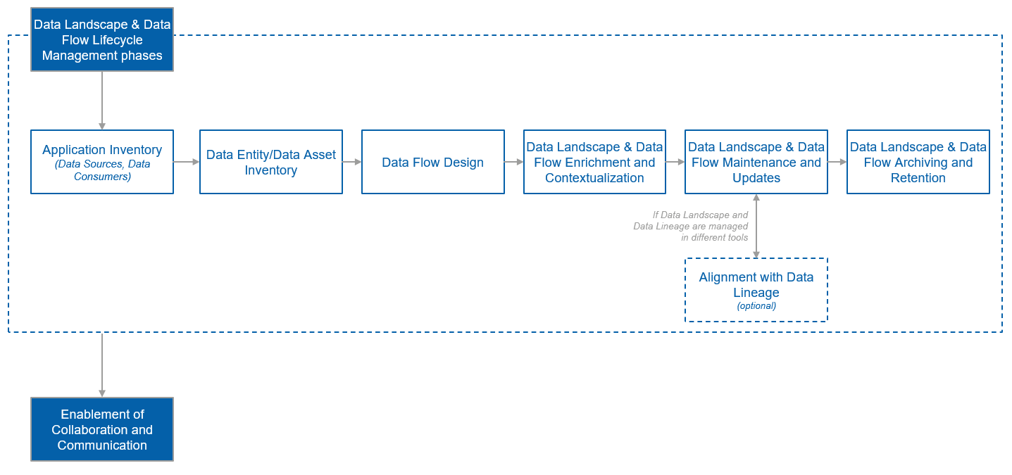
Figure #: Data Landscape & Data Flow Lifecycle Management (Process)

Data Landscape & Data Flow Management: Process
Order | Process Stage Name | Process Stage Description | Roles & Responsibilities | Application
1 | Application Inventory | To make an inventory of applications, systems, services where data is originated and consumed (moved through) across described business use case/s | Data Architects: Make application inventory engaged in required business process or use case.  Solution Architects: Assist data Architects to find out the correct information about required applications.  Domain Architects: Assist data Architects to make application inventory and/or validate it for relevance. | Data Catalog
2 | Data Entity/Data Asset Inventory | To make an inventory of Data Entities engaged to described business use case/s | Data Architects: Make Data Entity inventory engaged in required business process or use case.  Domain Architects, Data Stewards: Assist data Architects to make Data Entity inventory and/or validate it for relevance. | Data Catalog
3 | Data Flow Design | To design the data movement across applications with or without Data Entity detection | Data Architects: Design the data movement across inventoried applications, systems, services. | Data Catalog or ADONIS
4 | Data Landscape & Data Flow Enrichment and Contextualization | To enrich the Data Landscape & Data Flow diagram with more information via adding the secondary landscape components | Domain Architects: Assist Data Architects with business contextualization.  Data Architects: Add context to existing Data Landscape & Data Flow diagram via adding the secondary landscape components. | Data Catalog or ADONIS
5 | Data Landscape & Data Flow Maintenance and Updates | To maintain and update the Data Landscape & Data Flow diagrams | Data Architects: Maintain and update the Data Landscape & Data Flow diagrams to ensure their relevance and availability | Data Catalog or ADONIS
6 | Data Landscape & Data Flow Archiving and Retention | To retain and archive the Data Landscape & Data Flow diagrams | Data Architects: Retain and archive the Data Landscape & Data Flow diagrams | Data Catalog or ADONIS

Data Modeling Management Guidelines

Enterprise Data Model Management Guidelines

Enterprise Data Model Definition and Overview

Enterprise Data Model Management Guiding Principles

Enterprise Data Model Management Benefits

Enterprise Data Model Composition

Enterprise Data Model Management: Process

Enterprise Data Model Management: Process
Order | Process Stage Name | Process Stage Description | Roles & Responsibilities | Application Name

Solution Data Model Management Guidelines

Solution Data Model Definition and Overview

Solution Data Model Management Guiding Principles

Solution Data Model Management Benefits

Solution Data Model Composition

Solution Data Model Management: Process

Solution Data Model Management: Process
Order | Process Stage Name | Process Stage Description | Roles & Responsibilities | Application Name

Data Harmonization Guidelines

Transformation Technical Rules Guidelines

Transformation Technical Rules Definition and Overview

Transformation Technical Rules Guiding Principles

Transformation Technical Rules Benefits

Transformation Technical Rules Composition

Transformation Technical Rules: Process

Transformation Technical Rules: Process
Order | Process Stage Name | Process Stage Description | Roles & Responsibilities | Application Name

Data Mapping Guidelines

Data Mapping Definition and Overview

Data Mapping Guiding Principles

Data Mapping Benefits

Data Mapping Composition

Data Mapping: Process

Data Mapping: Process
Order | Process Stage Name | Process Stage Description | Roles & Responsibilities | Application Name

Metadata Management Guidelines

Metadata Management Overview
Metadata Management is a critical Data Architecture capability with empowers organization to navigate the complexities of data landscape by enhancing data discoverability, ensuring that critical information is readily accessible. Metadata describes the essence of data, enabling stakeholders to decipher its context and significance, which is essential for informed decision-making.

Metadata Types
Metadata is categorized into types to categorize and organize information about data in a structured manner. These categories serve different purposes within an organization's Data Management Processes.
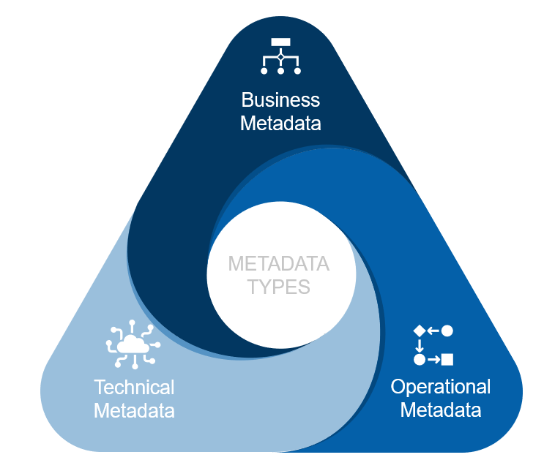
Figure #: Metadata Types
- Business Metadata refers to information that provides context and understanding about data from a business perspective. It focuses on the "what" and "why" of data, rather than the technical details of its storage or format. This type of metadata includes data definitions, descriptions of data elements, their meanings, and their relevance to an organization's operations and goals. Business metadata is essential for bridging the gap between technical data and business objectives, enabling better data management, decision-making, alignment with organizational strategies.
- Technical Metadata is data that provides information about the technical aspects and characteristics of data within an organization's information systems. It typically includes details about data structures, formats, and how data is stored and classified. Technical Metadata is essential for managing data storage, integration, processing, orchestration, and retrieval, as it helps stakeholders understand how data is organized and can be accessed – technical metadata typically contains information about interfaces data is exposed through, and the information about data structures may help sorting out an appropriate way of requesting / querying for data assets. Technical Metadata ensures that data can be effectively managed and utilized from a technical perspective within an organization.
- Operational Metadata is data that provides insights into the day-to-day operations of an organization's data systems and processes. It is primarily concerned with monitoring data as it flows through various systems and undergoes transformations. Operational metadata includes information such as data access logs, data change history, data workflow status, system performance metrics. This type of metadata is crucial for real-time monitoring of data activities, identifying issues, ensuring data quality, and maintaining the efficiency and reliability of data-related operations within an organization.
This categorization of metadata types aids in efficient data governance, quality assurance, and decision-making processes.
A Metadata Management Framework is a structured approach that outlines the processes, practices, and tools required to effectively manage metadata across Data Domains. It provides a systematic way to capture, store, organize, maintain, and leverage metadata, enabling better data understanding, governance, and decision-making. The following steps represent the framework:
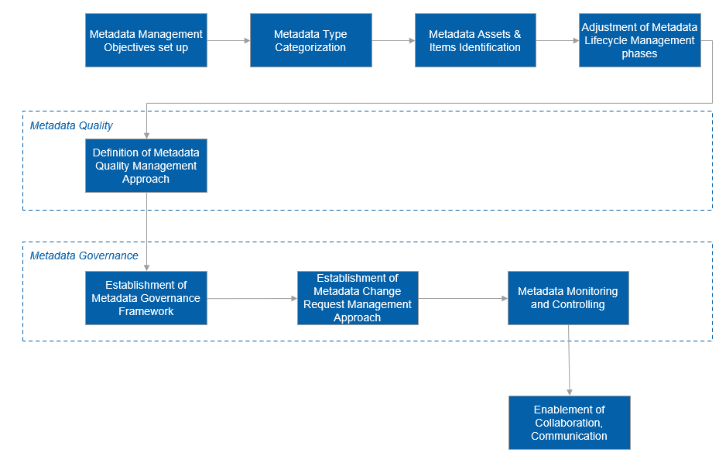
Figure #: Metadata Management Framework (Process)
- Metadata Management Objectives set up: By analyzing Data Management goals, objectives, strategy, data challenges and mitigation plans for them, key areas where Metadata Management can bring value (such as improving data quality, facilitating compliance, or enhancing data discovery) are to be identified and prioritized.
- Metadata Type Categorization: Basing on the metadata demand identified, the metadata must be categorized (e.g., technical metadata, business metadata, operational metadata) to find out appropriate management and governance processes and procedures for it.
- Metadata Assets & Items Identification: Identify metadata assets (Business Glossary, Data Dictionary, Business Assets, Technology Assets, Operational Assets) and their items (Business Term, Data Entity, Data Asset, Physical Data Repository) in a specific metadata category.
- Adjustment of Metadata Lifecycle Management phases: Define, plan, and adopt the processes of metadata collection, storage, cataloguing, enrichment, and contextualization in accordance with the demand specifics.
- Definition of Metadata Quality Management Approach: An approach of ensuring the accuracy, consistency, and completeness of metadata is to be defined and integrated into the metadata lifecycle.
- Establishment of Metadata Governance Framework: Taking into an account the metadata category, item, guidelines, that set standards, and best practices for metadata creation, storage, and usage are to be defined. Having the metadata governance framework introduced and sustained in day-to-day metadata management processes ensures that metadata is used across Data Domains in a unified and consistent way, and promotes metadata accuracy, integrity, and alignment with business objectives, regulatory compliance, and data quality standards.
Roles and responsibilities for metadata governance are to be specified and assigned.
  - Data Governance reps.: Set the strategic directions for metadata governance, ensuring alignment with Data Management objectives.
  - Data Owners: Assume accountability for specific metadata domains, ensuring their accuracy, relevance, and compliance.
  - Data Stewards: Responsible for day-to-day metadata management, including enrichment, quality control, and data context.
  - BFF reps: Manage the technical aspects of metadata storage, security, access, and governance enforcement.
- Establishment of Metadata Change Management Approach: A structured approach for managing metadata changes is to be defined, aligned with involved Data Domain stakeholders, and adopted according to the identified metadata category. It must be ensured that the changes are reflected in metadata governance policies, standards, and rules.
- Monitoring and Controlling: Key performance indicators to measure the effectiveness of metadata management are to be defined. Additional metrics indicating metadata usage, quality, and compliance dimensions are to be established to give more on the metadata value of the current state and trends.
- Enablement of Collaboration, Communication: Collaboration among data producers (this role may be assumed by partnering organizations which supply data assets to Novartis, Novartis data owners, or BFFs), data stewards, and data users is to be unlocked and facilitated. Communication channels for addressing metadata-related requests, updates, and changes are to be established and promoted.

Metadata Lifecycle Management
Metadata Lifecycle Management refers to the systematic management of metadata throughout its entire existence, from its creation or capture to its archiving or retirement. This lifecycle management ensures that metadata remains accurate, relevant, and useful for various data management and governance purposes. The Metadata Lifecycle consists of the following phases:
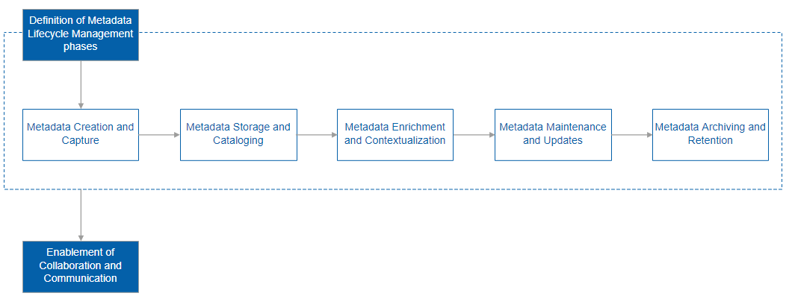
Figure #: Metadata Lifecycle Management (Process)

Order | Process Stage Name | Process Stage Description | Roles & Responsibilities
Across all phases | Collaboration and Communication | Throughout the metadata lifecycle, collaboration and communication occur across phases to ensure metadata accuracy and alignment with business objectives. | Data Stewards: Facilitate communication among stakeholders, address inquiries, and ensure metadata reflects changing requirements.  Data Consumers: Provide feedback on metadata quality, relevance, and usability to data stewards.
1 | Creation and Capture | This phase involves the initial generation or capture of metadata at the point of data creation or ingestion. It establishes the foundation for understanding the data's characteristics and context. | Data Producers: Responsible for attaching relevant metadata attributes during the data creation process.  Data Stewards: Oversee the accuracy and completeness of metadata at this stage, ensuring that essential metadata is captured.
2 | Storage and Cataloging | In this phase, metadata is organized and stored in catalogs and dictionaries. Metadata structures are defined to facilitate consistent storage and searchability. | Solution Architects: Manage the technical aspects of storing and organizing metadata in repositories or catalogs.  Data Stewards: Ensure metadata structures are aligned with business needs and metadata remains organized and searchable.
3 | Enrichment and Contextualization | Metadata is enhanced with additional context, relationships, and business meanings to improve data understanding and usage. | Data Stewards: Add context to metadata by providing additional descriptions, business definitions, and relationship mappings.  BFF and DO as subject matter experts: Contribute domain-specific knowledge to enrich metadata with relevant context.
4 | Maintenance and Updates | Regularly review and update metadata to reflect changes in data, business processes, and organizational needs. This phase ensures that metadata remains accurate and up to date. | Data Stewards: Responsible for maintaining the accuracy and relevance of metadata over time.  Data Owners: Collaborate with data stewards to validate and update metadata as data and business requirements evolve.
5 | Archiving and Retention | At the end of the metadata lifecycle, metadata may be archived for compliance, reference, or historical purposes. | Data Stewards: Manage the archiving of metadata, ensuring it is preserved and accessible for compliance and future reference.  ISC reps.: Determine metadata retention periods based on regulatory requirements and organizational policies.

Metadata Quality Management
Metadata Quality Management is a systematic approach to ensuring the accuracy, consistency, and completeness of metadata. Just as data quality is crucial for reliable insights and decision-making, metadata quality is equally essential to enable proper data understanding, discovery, and effective governance. Metadata Quality Management involves a series of steps and processes to maintain trustworthy metadata throughout its lifecycle:
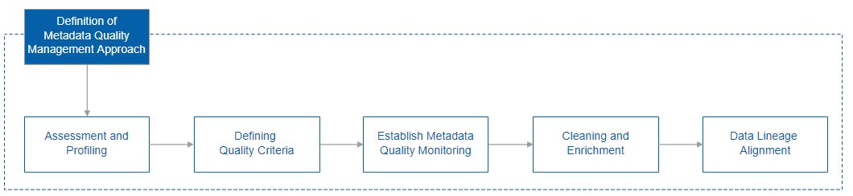
Figure #: Metadata Quality Management (Process)

Order | Process Stage Name | Process Stage Description | Roles & Responsibilities
1 | Assessment and Profiling | Analyze the current state of metadata quality to identify gaps, inconsistencies, and issues. | Data Stewards: Current state analysis at this step is based on interviews conducted with target groups of Data Domain representatives to identify pain points, challenges, issues, and foreseen opportunities.
2 | Defining Quality Criteria | Establish criteria and standards for metadata attributes (such as naming conventions and data relationships), ensuring they are aligned with business requirements. | Data Stewards: Define the quality criteria based on Business and Data Management needs and the identified pain points and opportunities.  (Enterprise) Data Architects: Assist data stewards with defining business-significant, feasible, and fit-for-purpose metadata quality criteria, taking into an account corresponding data specifics.  Data Architects: Plan quality criteria fulfillment, monitoring, and enforcement approaches.
3 | Establish Metadata Quality Monitoring | Establish automated monitoring and manual review processes to regularly validate metadata against the defined quality criteria to detect changes, inconsistencies, errors, or anomalies. | Based on the defined quality criteria  Data Stewards: Communicate with Data Domain reps. regarding if the established quality criteria accurately reflect the challenges they face; whether the collected quality state statistics describe the situation in full and highlights the priorities and impact significance correctly.  Data Architects: Ensure that the quality collection, monitoring, and reporting features are and integrated and automated.
4 | Cleaning and Enrichment | Correct identified inaccuracies, inconsistencies, and errors in metadata. Add relevant context, description, and relationships to improve data understanding. | Data Stewards: Initiate and manage change requests (see the dedicated section for more details).  Data Architects: Provide a detailed information about the Data Management context adjacent to the change request.
5 | Data Lineage Alignment | Regularly verify and align metadata quality checks with data lineage to ensure metadata accurately reflects data transformations and dependencies. | Data Steward, Data Architect, Solution Architect.

Metadata Change Request Management
Metadata Change Request Management is the process within Metadata Governance that oversees modifications made to metadata. Controlled alterations ensure that changes to metadata attributes, definitions, relationships, and structures are validated, documented, and in line with business and data goals and standards.
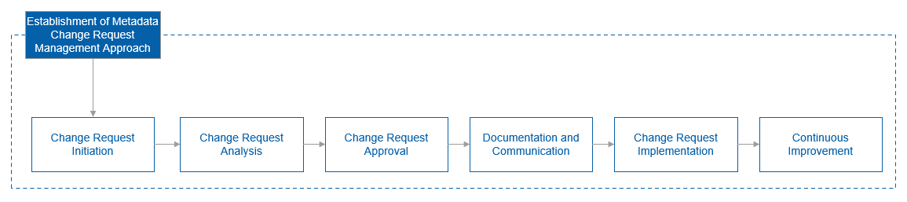
Figure #: Metadata Change Request Management (Process)

Order | Process Stage Name | Process Stage Description | Roles & Responsibilities
1 | Change Request Initiation | The process begins with a request for a metadata change, which could involve adding, modifying, or retiring metadata attributes. | Metadata Stakeholders: Initiate the change request based on business needs.  Data Stewards: Receive and document the change request.
2 | Change Request Analysis | The change request is analyzed to determine its impact, feasibility, and alignment with existing metadata standards. | Data Stewards: Review the change request, assesses its impact, and proposes potential solutions.  BFF Data Architects: Work together with data stewards to align metadata change with Data Management demand.  Solution Architects: Evaluate technical implications of the proposed change.  BFF and DO reps.: Evaluate the impact on business processes.
3 | Change Request Approval | The proposed change is submitted for review and approval by relevant Governing Body, which apart from checking feasibility and rationale, ensures alignment with business and data goals and standards. | Governing Body: Reviews and approves changes based on their impact, benefits, and compliance.
4 | Documentation and Communication | The approved change is documented along with its rationale, impact analysis, and associated metadata attributes. | Data Stewards: Document the approved change in the metadata repository. Communicate the change to relevant teams, ensuring awareness.
5 | Change Request Implementation | The metadata change is executed, involving modifications to metadata attributes, definitions, relationships, or structures. | Data Stewards: Execute the metadata change, update the metadata repository, and enforce data quality checks.  BFF Solution Architects: Facilitate implementation of technical changes, ensuring data lineage is updated accurately.
6 | Continuous Improvement | After implementation, a review is conducted to assess the success of the change and identify areas for improvement in the change management process. | Governing Body: Reviews the change's impact and process effectiveness.  Data Stewards: Provide insights into the efficiency and effectiveness of the change implementation.

Data Catalog Guidelines

Data Catalog Definition and Overview
Data Catalog is a centralized repository or database that contains metadata and information about all the data assets within an organization. It serves as a comprehensive inventory and reference system for data, providing users with a clear and organized view of available datasets, their characteristics, and relationships.
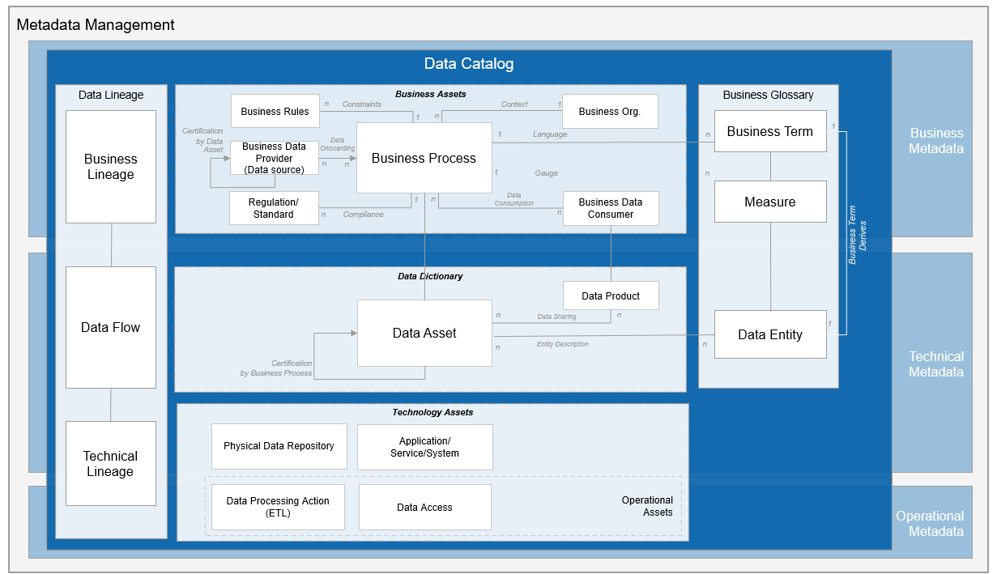
Figure #: Data Catalog High-level Structure

Data Catalog Guiding Principles

Data Catalog Benefits
Data Catalog is an essential tool for enhancing data management, data discovery, and data collaboration. It enables organization to harness the full potential of their data assets, improve decision-making, and gain a competitive advantage in today's data-driven landscape.
- Data Discovery: Data catalogs make it easier for users to find and access the data they need for analysis, reporting, or other data-related tasks. Instead of spending significant time searching for data across various sources, users can quickly locate relevant datasets in the catalog.
- Data Governance: Data catalogs help enforce data governance policies, access controls, and data security measures. They ensure that sensitive data is appropriately managed, accessed by authorized users only, and comply with relevant data regulations.
- Data Quality Assessment: Data catalogs often include data quality metrics and profiling information, allowing users to assess data reliability before utilizing it in their analyses or applications.
- Data Transparency: By providing detailed metadata and descriptions, data catalogs promote transparency and understanding of the available data assets. Users can assess the data's quality, relevance, and suitability for their purposes.
- Data Collaboration: With social features like comments and annotations, data catalogs foster collaboration among users. Team members can share insights, knowledge, and feedback about specific datasets, enhancing overall data understanding and collective decision-making.
- Data Lineage and Impact Analysis: Understanding the data lineage — how data has been sourced, transformed, and processed — provides insights into data origin and dependencies. It helps users track data changes and analyze potential impacts on downstream processes.

Business Glossary Guidelines
      - Business Glossary Definition and Overview
A business glossary is a collection of business concepts, measures, guidelines, and rules – business glossary items, that organizations use to ensure the same definitions are used company-wide, thus enabling common language across the enterprise.
A business glossary contains metadata (describes various attributes and characteristics of a particular original data) that assigns meaning or semantic context to corresponding organizational assets.
      - Business Glossary Guiding Principles
- Ensure that a business glossary is closely aligned with organization's business objectives and goals. This guarantees that the defined terms, relations, and constraints directly support business processes and strategic initiatives.
- Define key performance indicators to gauge the effectiveness and efficiency of an established business glossary, such as usage and adoption metrics, resource utilization metrics, waste reduction metrics, and others. Regularly verify that the defined KPIs help evaluating the extent of support the business glossary provides to organization’s business goals.
- Assign data stewards and owners responsible for creating, maintaining, and validating glossary business terms. Clearly defined ownership ensures accountability for the accuracy and relevance of definitions.
- Involve stakeholders from different Data Domains and roles in creating and maintaining a business glossary. This promotes a comprehensive and common understanding of and collaboration on the business terms across the organization.
- Implement standardized version control and change management processes to track and report updates to a business glossary. This ensures that historical definitions are preserved in a consistent manner, and that changes are carefully managed.
- Schedule regular reviews of a business glossary structure, content, and processes to keep it current with evolving business needs and business processes. Stale glossaries can lead to confusion and misalignment.
- Integrate a business glossary into a broader data governance framework. This ensures that glossary terms are used consistently in data documentation, data lineage, data quality, and other data management initiatives.
      - Business Glossary Benefits
The following benefits are provided when a business glossary is introduced, adopted, and sustained within an organization:
- Reduced risks of data misuse due to inconsistent understanding of business concepts.
- Increased work effectiveness -- when all parties involved have an easy access to a business glossary, as well as a mutual understanding of business concepts and how they correlate with various data assets and metrics, it reduces errors and delays on how data should be transformed into useful information and insights.
- Increased trust in organization’s data assets due to the additional effort invested by data owners and data stewards into governance and curation.
- Improved alignment between technology and business structures.
- Avoided cost of data investments due to the enabled data asset reuse.
      - Business Glossary Composition
A Business Data Glossary is organized in a structured and systematic manner to ensure clarity and easy access to information.
It serves as a reference guide to ensure consistency and clarity about data-related concepts across different teams and departments.
The primary purpose of a data glossary is to provide a common understanding of the terminology and definitions used within an organization.

Business Term
A Business Term (handled within a business glossary) is a word or phrase that uses business language to define a relevant business fact or an entity for business users in an organization. Terms are fundamental building blocks of a business glossary.
Data Stewards defines a description of a term, its required and optional attributes.
Attribute | Description
Identifier | A code unique throughout the whole organization.
Name | A word or a combination of words by which the concept is designated, called, or known by.
Definition | A business description. There are several rules of filling out this attribute:  It must be provided in a business language and show relevance to a particular business case, situation, event, or process.  It must be stated in the present tense.  It must not use any of the words found in the name of the concept being defined.  It must not include acronyms or abbreviations.
Category | A term group that specifies its location in a business glossary hierarchy.
Information Type | Master data. Represents the key business entities and their attributes that remain relatively stable over time -- typically includes information about fundamental business entities, such as customers, products, vendors, employees, locations, and assets.  Reference data. Refers to the fixed, unchanging, and standardized values used to categorize, classify, or describe other data. Examples include:  Country codes (ISO codes like "US" for the United States or "CA" for Canada)  Currency codes (ISO codes like "USD" for the US Dollar or "EUR" for the Euro)  Customer segments (e.g., premium, regular, VIP)  Transactional data. Refers to the information generated and recorded during various business interactions or events within an organization's operational systems. These transactions could include sales, purchases, orders, inventory movements, financial transactions, customer interactions, and more. Transactional data is typically characterized by its detailed and granular nature, capturing individual events or actions as they occur in real-time.
Primary Business Owner | A person who is authorized to make decisions about any aspect of a concept’s lifecycle.
Owning Data Domain | A Data Domain that is accountable for a concept relevance, consistency, and quality. If the concept refers to a global business abstraction being reused extensively by many Data Domains (and thus no specific Owning Data Domain could be nominated), ‘Enterprise’ Data Domain should be assigned.
Data Steward(s) | Experts who has created the concept and are responsible for keeping it relevant, consistent and up to date.
Status | A lifecycle step the concept resides at. The value of this attribute changes when a Data Steward defines, proposes, or publishes a business concept.  A concept can exist in one of the following phases:  Draft. Indicates that a Data Steward created the business concept.  In Review. Indicates that a Data Steward proposed the concept – and it is under a validation by a Reviewer.  Rejected. Indicates that the Reviewer found issues or gaps in the concept definition.  Approved. Indicates that the Reviewer accepted the concept definition.  Published. Indicates that the Data Steward made the concept accessible to a wide audience.
Created Date | Date when this business concept was created. The format to be used is day / month / year.
Created By | Name of a person (typically a Data Steward) who proposed this business concept.
Last Modified Date | Date of the latest occasion of some business concept attribute change. The format to be used is day / month / year.
Last Modified By | Name of a person (typically a Data Steward) who recently made a change of some business concept attributes.

Other (optional) attributes of a business concept further explain it and thus help consumers better understand its applicability for particular (business) situations.
Attribute | Description
Secondary Business Owner(s) | Individuals, authorized to make decisions about any aspect of a concept’s lifecycle in case a primary business owner is not accessible.
Abbreviations | Short form(s) (acronym(s) typically) of the concept.
Synonyms | Concepts that have the same meaning. A concept can have multiple synonym concepts. The relationship is symmetrical and transitive. If concept A is a synonym of concept B, and concept B is a synonym of concept C, each concept is a synonym of the others.
Governing Business Guidelines | Specifies business guidelines that this concept is controlled by.
Governing Business Rules | Specifies business rules that this concept is controlled by.
Associated Data Assets | Assets (such as reports) that can be associated with the concept. Multiple assets can be linked to a single concept. An asset can be linked to multiple concepts.
Related Business Concepts | Concepts that are related in some way to the current concept. The relationship is symmetrical -- if it is specified that concept A has concept B as a related concept, then concept B has concept A as a related concept. A concept can have multiple related concepts.
Related Business Processes | Business processes that contain or are described with the current concept.
Related Data Domains | Data Domains that use this concept within its key data exchange processes.
Usage | Information about how to use the concept in a particular (business) context. May also contain a sample of how the concept is used and its typical value(s) in a particular business situation.
Label | A simple, short descriptor that can be used as another way of a (semantical) concept grouping.
Notes | Any additional text information about the concept.

Data Entity
A Data Entity represents a real-world concept that plays a significant role in an organization's operations and processes. The entities are characterized by attributes that describe and define these entities within the context of an organization. Data entities serve as fundamental building blocks in organizing information flows of a company, representing and structuring data in a meaningful and consistent manner.
More precisely, while a business concept defines an (business significant) object, giving it a business meaning – semantics, in the way a physical dictionary does that (e.g., Merriam-Webster dictionary), Data Entities define the same object by specifying its conceptual and logical structure – key attributes, that collectively describe a unique genesis and behavior of the object.
Data Entity identification process is a crucial step in organizing a Business Glossary:

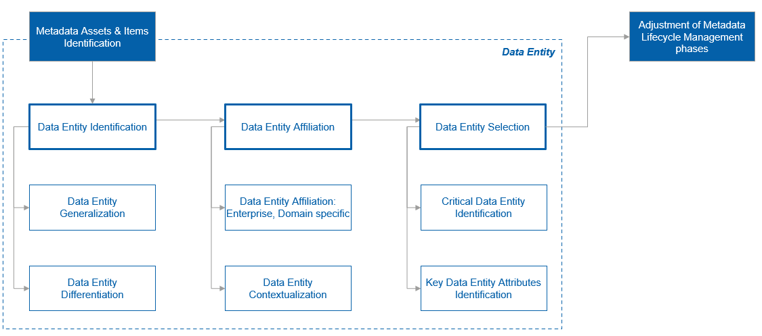
Figure #: Data Entity Identification (Process)
Order | Process Stage Name | Process Stage Description | Roles & Responsibilities
1 | Data Entity Identification
2 | Data Entity Affiliation
3 | Data Entity Selection

- Data Entity Identification
A prerequisite for a data entity identification is to have key business processes modelled and documented. With these artifacts in place, the first iteration of finding data entities may be as simple as collecting the nouns in descriptions of the business processes, business plans, and business strategies that describe key concepts and interactions between the involved parties (internal and external).
While collecting the candidate entities, it is important to additionally describe their roles in the business, relationships to other entities, and any information about the entity’s lifecycle.
Example
Medical Congress and Conferences Planning (MCCP): MCCP is a business process of when a marketing team designs a comprehensive marketing plan during events like conferences, which includes various communication channels such as emails, webinars, in-person visits, and virtual meetings. The team plans a sequence of engagements for each healthcare professionals (HCPs) and healthcare organizations (HCOs), taking into an account factors like their preferred communication channels, availability, and past interactions.
In this business process the following data entity candidates can be elicited:
- HCP – refers to individuals who are licensed, certified, or otherwise authorized to provide medical and healthcare services to patients.
- HCO – refers to any institution or facility that provides healthcare services to patients. This can include hospitals, clinics, medical practices, nursing homes, outpatient facilities, and other healthcare-related establishments.
- Event – refers to a planned gathering or assembly of healthcare professionals, researchers, scientists, pharmaceutical industry representatives, and other stakeholders with a common interest in discussing and exchanging knowledge about medical and healthcare-related topics. These events serve as platforms for education, networking, sharing research findings, and showcasing pharmaceutical products and services.
- Communication channel -- It's a pathway through which communication flows, connecting pharmaceutical companies, healthcare professionals, researchers, attendees, and other stakeholders during Events like medical congresses and conferences. Communication channels play a critical role in effectively delivering key messages, promoting pharmaceutical products, sharing research findings, and facilitating interactions among participants.

Data Entities must be frequently re-evaluated, reorganized, and redefined (if needed) to ensure that they are serving the purpose for the organization.

There are several ways to refine the collected Data Entity candidates. Generalization and differentiation are two approaches of the refinement, which involve adding or deleting entities, renaming entities, assigning, and reassigning different attributes. Generalization is the approach of creating a single (unified) data entity from several other data entities by combining their behavior and lifecycles. Conversely, Differentiation focuses on creating specialized data entities for distinct business and data segments.

The choice between these approaches depends on the context, objectives, and data characteristics.

- Data Entity Generalization: The primary goal of using generalization, is to gain a comprehensive and unified view of data from various sources, enabling identification of common trends, patterns, and insights that apply across multiple business and data segments.
Generalization is utilized:
- When differences between data entities are relatively minor, and combining them can simplify data management and analysis, making efficient use of resources.
- When data entities share similar goals and objectives, generalization allows to assess progress and performance in a unified manner.
- When data decisions are to be applied broadly across Data Domains, and the goal is to collect wide-scoped insights (e.g., common change directions).
Example
Market segmentation: Combining data on prescription patterns from HCPs and HCOs provides a unified understanding of medicinal product adoption trends across the entire market.
Market share assessment: When assessing a company's market share, combining data from different territories provides an aggregated view of how well the medicinal products are performing in various markets.

  - Data Entity Differentiation is used when there is a need of tailoring strategies for distinct business and data segments with unique characteristics.
This approach should be selected if:
    - Having separate data entities provides a clearer understanding of segment-specific outcomes, and thus business decisions could be made based on unique characteristics and behavior of each data entity.
    - Data entities have distinct properties, structures, and contexts that don't align well in a combined view.
Example
Marketing campaign customization: Splitting the data entity of Customer to HCPs and HCOs enables creating distinct marketing campaigns. For HCPs, campaigns can focus on clinical efficacy, while campaigns for HCOs can highlight cost-effectiveness outcomes.
Geographical strategy tailoring: Separate data on prescription patterns for different Territories allows customizing marketing strategies based on regional regulations, patient demographics, and healthcare infrastructure.

- Data Entity Affiliation
A typical question that arises upon a new data entity elicitation is which organizational level this entity should be affiliated to, i.e., whether the entity lives at an enterprise level, if it should become a part of an existing data domain, or a brand-new data domain or sub-domain must be created for it.
There are two organizational grades to be considered:
Data Domain Entity | Enterprise Entity
Focus
Refers to a specific data entity that represents a distinct category or group of related objects within a particular Data Domain. | Emphasizes a broader perspective (than the domain level) that encompasses the entire organization. It indicates that the data entity is relevant and critical to the overall functioning and strategic objectives of the entire enterprise.
Scope
While staying within a Data Domain, the scope of a domain data entity extends across various business areas, functions, or departments within an organization. It is not limited to a specific department but instead spans multiple parts of the organization that share a common need for the data represented by the entity. | Enterprise data entities are designed to be more comprehensive and applicable across multiple business units and Data Domains. They aim to capture data that is shared and utilized at the enterprise level, providing a holistic view of the organization's data flows.
Context
The context of a domain data entity lies within the data domain to which it belongs. | The aim is on understanding how data is integrated, shared, and utilized across the organization to enable data-driven decision-making and support various business functions.

To identify an appropriate place at a company’s data landscape for a data entity several aspects should be analyzed:
- Business demand
- Inter-entity dependencies
- Ownership
- Financial footprint
- Unit capacity for handling data entities

Though, even after elaborating all these aspects, it could still be not crystal clear where a particular entity should be affiliated to. For that reason, an assigned Data Steward should consult with a corresponding Governing Body (e.g., Enterprise Data Architects for enterprise data entity candidates), who gives the final approval for the entity placement basing on a business objectives, strategy, and cost-benefits analysis.
A major criterion for identifying a data entity affiliation is accountability. This is where an ownership for the decision-making about data entity lifecycle aspects takes place.
  - Data Entity Affiliation Guideline
Data Domain Entity | Enterprise Entity
Domain data entities are bound within a specific business context, hence they may involve unique business rules and logic that are tailored to the specific needs of the Domain, which might make them of a limited relevance or use outside of their designated domain. | Enterprise data entities are used across various business functions and Data Domains. They provide a comprehensive view of organization's operations and performance, thus the ownership for these overarching items is assigned to Enterprise Data Architects.
Example
- Drug formulation specifications – detailed data on the composition and characteristics of a drug's formulation, including excipients, API percentages, and dosage forms. This data guides production processes.  - Equipment calibration records -- data related to the calibration of production equipment, ensuring accurate and reliable manufacturing processes. | - Regulatory compliance data -- information about regulatory requirements, approvals, and compliance status for various drugs and manufacturing processes. Ensuring compliance is critical to avoid legal and financial risks.  - Research and medicinal product development portfolio -- details of ongoing research projects, clinical trials, and medicinal product development initiatives.

  - Data Entity Contextualization
There could be cases of a data entity contextualization – the occasion of adopting and customizing an enterprise data entity by a data domain for better serving the domain’s internal needs. This is where key data entity attributes stay unchanged, while new (contextualized) attributes are added to the entity to reflect the data domain specifics.
Physically, data entity contextualization results in creating a new (child) data entity for the needs of a (contextualizing) Data Domain with the ownership assigned to this Data Domain for the data entity.
The difference, however, between a contextualization and a typical domain data entity creation is that when the former happens, a complex relationship between the parent (enterprise) and the child (data domain) entities is established -- a federated governance approach is applied to the contextualized data entity. Generic governance is still provided from the enterprise level (high-level data entity lifecycle and attribute constraints), while the contextualizing data domain manages additional entity behavior (lifecycle) in accordance to its requirements.
Example
For instance, if a Supply Chain domain wants to localize an enterprise entity of Medicinal Product for the purpose of controlling and monitoring adherence to Falsified Medicines Legislation (FMD) by adding new characteristics (e.g., safety features) and new lifecycle steps (e.g., checking and labeling drugs for FMD compliance) to it, the Supply Chain domain creates a new data entity referred as FMDC (FMD Compliant) Medicinal Product which inherits required Medicinal Product’s attributes (incl. their constraints) and lifecycle, and is filled with additional FMD-related attributes, lifecycle steps, and constraints. Thus, while Medicinal Product remains being an enterprise entity with its associated ownership and governance, it also shapes the way Supply Chain’s FMDC Medicinal Product is operated over. The Supply chain domain, in its turn, can make authoritative decisions about the contextualized usage of its FMDC Medicinal Product (domain) entity adhering to higher-level governance requirements of Medicinal Product data entity.

- Data Entity Selection
Trying to govern, measure, and manage all data entities that an organization has can be an overwhelming and financially infeasible exercise. Determining and prioritizing data entities (from the collected candidates) is one of the first steps to successfully managing data for meeting business objectives.
Critical Data Entity Identification
All collected data entity candidates are not created equal, and hence do not have the same level of importance. Only a portion of them is significant for business at a certain stage of maturity – those entities have direct or indirect (financial) impact to the organization, and thus deserve resource investments.
After several data entity identification iterations performed, there could be quite a few candidates, and to crystallize business significant ones critical entities need to be selected, where the criticality represents the extent to which an entity supports enterprise obligations or critical business functions or processes, and will cause customer dissatisfaction, pose a compliance risk, or have a direct financial impact if the quality or value of it is not sufficient enough (e.g., a data entity of HCP is widely used across organization’s business processes and typically contain an individual’s full name and home address – sensitive attributes from the PII management perspective, hence are regulated by laws and if not properly secured can cause significant penalties from a regulation authority; With that, due to its use and financial impact HCP may be considered as a critical data entity). Organizations must ensure that critical data entities and their attributes are of high quality, governed rigorously, and the purposes of their usage are precisely tracked.
There is a formal method of eliciting critical data entities – the factor rating method. It involves determining the factors, rating schema, weights associated with each factor, and defining a formula to calculate the final score. After the scores are evaluated for each candidate entity, they should be sorted in the descending order, which gives a rank – an indicator of criticality.

Two most common factors are used to determine critical data elements are:
- Number of business obligations or use cases for which a data entity is critical (as entities that are critical for one business obligation or use case may not be critical for another business obligation or use case). There are several ways to identify the data entity criticality, including:
  - Engage key stakeholders / SMEs involved or impacted by the use case and let them to decide.
  - Conduct an impact analysis to understand the consequences of failures of the data entity under a consideration, e.g., if in case of a bad data quality the whole use case shall be ruined, or business shall acquire a negative impact, the data entity is critical.
- The impact in case a data entity does not fit for use or is exposed to unauthorized access. As previously mentioned, impacts can be financial, regulatory, legal, reputational damage, customer dissatisfaction or a combination of these.

The following table shows an example of the impact rating:
Impact | Rating
No impact | 0
Low Impact | 1
Moderate Impact | 2
High Impact | 3

The criticality score is calculated as follows:
Criticality Score (C) = Number of business obligations or use cases for which the data elements are critical (N) * Impact Rating (I).
The entities with the highest score should be considered as business critical and be taken into consideration first from the management, governance, and quality improvement perspectives.
EXAMPLE
The following table is provided for illustrative purpose only and does not adhere to real Novartis data landscape.
Data Entity Candidate | Number of business obligations or use cases for which the entity is critical (N) | Impact rating (I) | Criticality score  C = (N*I)
Product | 35 | 2 | 70
Supplier | 16 | 3 | 48
Customer | 14 | 3 | 42
Order | 20 | 2 | 40
Purchase Order | 10 | 2 | 20
Company | 2 | 0 | 0
Stock | 3 | 0 | 0

From the table above the candidate entities of Product, Supplier, Customer, and Order deserve to be nominated as (critical) data entities, taking the value of 40 as a criticality indication watermark.
This method can be used as well for identifying domain and sub-domain critical entities. For instance, looking at the table above, the entity of Purchase Order does not have a big enough criticality score to be treated as a (significant) data entity, so shall be skipped.
After critical data entities are elicited and their affiliations are determined, key attributes for them are to be defined, as the attributes give every entity an identity and unlock the process of semantical alignment of entities across data domains.
Critical Data Entity Attributes Identification
Attributes supply informational details to the entity and can be required and optional. An entity can have one or several attributes. Each instance of an entity must contain values for all the required attributes to define it.
By following the same approach as for data entities, key attributes associated with entities can be identified by examining:
- Business functions and business processes.
- Entity relationship and lifecycle specifics collected during the data entity elicitation.

Measures: Metrics, KPIs and Benchmarks
A Measure is a general term used to describe the act of assessing or quantifying something. It is a way to assign a numerical value or quantity to an attribute, or characteristic of an object or phenomenon. Measures are utilized to obtain objective data for analysis, comparison, or evaluation.
Within a business glossary, the following types of measures are typically defined at the same level as of business concept: Metric, KPI, Benchmark.
The following attributes are required to every measure type:
Attribute | Description
Identifier | A code unique throughout the whole organization.
Name | A word or a combination of words by which the measure is designated, called, or known by.
Definition | A clear and concise description of what the business measure represents, its purpose, and how it is calculated. This helps ensure a shared understanding of the measure's meaning. There are several rules of filling out this attribute:  - It must be provided in a business language and show relevance to a particular business case, situation, event, or process.  - It must be stated in the present tense.  - It must not use any of the words found in the name of the measure being defined.  - It must not include acronyms or abbreviations.
Calculation Methodology | Detailed instructions on how to calculate the business measure from the underlying data. This includes any formulas, algorithms, or data transformations involved.
Data Granularity | The level of detail at which the data is collected and measured. For example, daily, weekly, monthly, or yearly granularity.
Expression Type | The measure expression type used for the business measure, such as numeric, percentage, count, etc.
Units of Measurement | The units in which the business measure is expressed (e.g., dollars, units, hours).
Measure Type | A metric, a benchmark, or a KPI.
Category | A measure group that specifies its location in a business glossary hierarchy.
Primary Business Owner | A person who is authorized to make decisions about any aspect of a measure’s lifecycle.
Owning Data Domain | A Data Domain that is accountable for a concept relevance, consistency, and quality. If the concept refers to a global business abstraction being reused extensively by many Data Domains (and thus no specific Owning Data Domain could be nominated), ‘Enterprise’ Data Domain should be assigned.
Data Steward | A person who created the concept and is responsible for keeping it relevant, consistent and up to date.

While the ones below are optional:
Attribute | Description
Secondary Business Owner(s) | Individuals, authorized to make decisions about any aspect of a measure’s lifecycle in case a primary business owner is not accessible.
Abbreviations | Short form(s) (acronym(s) typically) of the concept.
Reference Value | Defined value to compare with. Mainly used for KPIs and benchmarks.
Governing Business Guidelines | Specifies business guidelines that this concept is controlled by.
Governing Business Rules | Specifies business rules that this concept is controlled by.
Related Data Assets | Assets (such as reports) that can be associated with the concept. Multiple assets can be assigned to a single concept. An asset can be assigned to multiple concepts.
Related Concepts | Concepts that are related in some way to the current concept. The relationship is symmetrical -- if it is specified that concept A has concept B as a related concept, then concept B has concept A as a related concept. A concept can have multiple related concepts.
Related Business Processes | Business processes that contain or are described with the current concept.
Related Data Domains | Data Domains that use this concept within its key data exchange processes.
Related Measures | Information on any other business measures, metrics, or data elements that the current business measure relies on.
Usage | Information about how to use the concept in a particular (business) context. May also contain a sample of how the concept is used and its typical value(s) in a particular business situation.
Label | A simple, short descriptor that can be used as another way of a (semantical) concept grouping.
Notes | Any additional text information about the concept.

A Metric is a specific type of measure that is used within a particular context or domain to quantify and evaluate performance, efficiency, quality, or other aspects of interest. Metrics are usually defined with a clear purpose and are used as a standard for making decisions or improvements.
Key Performance Indicators (KPIs) are measurable values that indicate how well an organization or initiative is achieving their objectives or goals. KPI can be used to monitor and evaluate the performance and effectiveness of various aspects of Data Architecture.
(Data) benchmarks refer to standardized tests or performance measurements used to evaluate the capabilities and efficiency of data initiatives or computational components in handling specific data-related tasks, where these benchmarks are designed to provide objective and comparable metrics.
While benchmarks provide valuable insights into performance, real-world workloads can differ significantly from benchmark scenarios, so it is essential to consider the specific use case and workload.

Categories
A category is a descriptive classification of business concepts, business guidelines and rules. Categories provide a logical structure for a business glossary so that consumers can browse and understand the (semantical) relationships between the assets.
Categories are characterized in a business glossary by the values of their attributes. The following category attributes are required:
Attribute | Description
Identifier | A code unique throughout the whole organization.
Name | A word or a combination of words by which the category is designated, called, or known by.
Definition | A business description. There are several rules of filling out this attribute:  - It must be provided in a business language and show relevance to a particular business case, situation, event, or process.  - It must be stated in the present tense.  - It must not use any of the words found in the name of the category being defined.  - It must not include acronyms or abbreviations.
Owning Data Domain | A Data Domain that is accountable for a category relevance, consistency, and quality. If no specific Owning Data Domain could be nominated, ‘Enterprise’ Data Domain should be assigned.
Primary Business Owner | A person who is authorized to make decisions about any aspect of a category’s lifecycle.
Data Steward | A person who created the category and is responsible for keeping it and its concept associations relevant, consistent and up to date.
Parent Category | The category that contains this category as a subcategory.
Other (optional) attributes of a category further explain it and thus help consumers better understand its applicability for particular (business) situations.
Attribute | Description
Secondary Business Owner(s) | Individuals, authorized to make decisions about any aspect of a category’s lifecycle in case a primary business owner is not accessible.
Label | A simple, short descriptor that can be used as another way to describe the category (and group semantically related categories).
Notes | Any additional text information about the category.

Example of a category definition
The business concept of “Medicinal product” may be categorized and introduced into the business glossary hierarchy like:
Attribute | Value
Identifier | CAT-IDF-001
Name | Vaccines
Definition | Vaccines are biological preparations that stimulate the immune system to provide immunity against specific diseases. They are used to prevent infectious diseases.
Owning Data Domain | Medicinal products
Primary Business Owner | John Doe
Data Steward | Jane Smith
Parent Category | Products

Business Guidelines
A business guideline is a natural-language phrase that outlines the general intent and framework business glossary items need to follow to stay compliant with corporate standards and requirements.

Business guidelines can be organized in a hierarchy based on their meaning and relationships to one another. Each business guideline can contain multiple business sub-guidelines. Each business guideline can reference one or more business rules.
Business guidelines are characterized in a business glossary by the values of their attributes.
Attribute | Description
Identifier | A code unique throughout the whole organization.
Name | A word or a combination of words by which the business guideline is designated, called, or known by.
Definition | A business description. There are several rules of filling out this attribute:  - It must be provided in a business language and show relevance to a particular business case, situation, event, or process.  - It must be stated in the present tense.  - It should contain a reference to a corresponding standard or legal regulation.
Owning Data Domain | A Data Domain that is accountable for a guideline relevance, consistency, and quality. If the guideline is heavily reused by many Data Domains (and thus no specific Owning Data Domain could be nominated), ‘Enterprise’ Data Domain should be assigned.
Primary Business Owner | A person who is authorized to make decisions about any aspect of a business guideline’s lifecycle.
Data Steward | A person who created the guideline and is responsible for keeping it and its asset associations relevant, consistent and up-to-date.
Category | A guideline group that specifies the guideline’s location in a business glossary hierarchy.
Other (optional) attributes of a business guideline that further explain it and thus help consumers better understand its applicability for particular (business) situations.
Attribute | Description
Secondary Business Owner(s) | Individuals, authorized to make decisions about any aspect of a business guideline’s lifecycle in case a primary business owner is not accessible.
Parent Guideline | The business guideline that contains this guideline as a sub-guideline.
Related Rules | Business rules that help executing this business guideline.
Concepts | Concepts that are governed by this business guideline.
Usage | Information about how to apply this guideline in a particular (business) context. It may give instructions and guidelines for executing the guideline. It may also contain illustrative examples for giving more clarity on the guideline application.
Label | A simple, short descriptor that can be used as another way to describe the business guideline (and group semantically related business guidelines).
Notes | Any additional text information about the business guideline.

Example of a business guideline definition
The business concept of “Medicinal product” should be governed. One of business guidelines that could be used for this purpose is:
Attribute | Value
Identifier | BIZGUID-IDF-001
Name | Vaccine code allowance
Definition | The National Center of Immunization and Respiratory Diseases (NCIRD) developed and maintains the CVX (vaccine administered) code set. It includes both active and inactive vaccines available in the US. CVX codes should be used instead of Current Procedural Terminology (CPT™) ones.
Owning Data Domain | Medicinal products
Primary Business Owner | John Doe
Data Steward | Jane Smith
Category | Product Governance
Usage | These codes should be used for immunization messages using either HL7 Version 2.3.1 or HL7 Version 2.5.1.

Business Rules
A business rule is a natural-language description of the criteria that are used to determine whether a business glossary item is compliant with business objectives. It is a specific and detailed set of conditions that must be met by the business glossary item to comply with the established business requirements.
When a business rule is created, corresponding business guidelines may be referenced. A business rule can be associated with zero, one, or multiple business guidelines.
Business rules are characterized in a business glossary by the values of their attributes.
Attribute | Description
Identifier | A code unique throughout the whole organization.
Name | A word or a combination of words by which the business rule is designated, called, or known by.
Definition | A business description. There are several rules of filling out this attribute:  - It must be provided in a business language and show relevance to a particular business case, situation, event, or process.  - It must be stated in the present tense.  - It may contain a reference to a corresponding standard, legal regulation, and business guidelines.
Owning Data Domain | A Data Domain that is accountable for a rule relevance, consistency, and quality. If the rule is heavily reused by many Data Domains (and thus no specific Owning Data Domain could be nominated), ‘Enterprise’ Data Domain should be assigned.
Primary Business Owner | A person who is authorized to make decisions about any aspect of a business rule’s lifecycle.
Data Steward | A person who created the business rule and is responsible for keeping it and its asset associations relevant, consistent and up-to-date.
Category | A business rule group that specifies the rule’s location in a business glossary hierarchy.
Other (optional) attributes of a business rule further explain it and thus help consumers better understand its applicability for particular (business) situations.
Attribute | Description
Secondary Business Owner(s) | Individuals, authorized to make decisions about any aspect of a business rule’s lifecycle in case a primary business owner is not accessible.
Governs | Assets that the business rule governs or should govern.
Referencing business guidelines | Business guidelines that are associated with this business rule. A rule can be referenced by zero or more business guidelines.
Related Rules | Business rules that are related in some way to the current rule. The relationship is symmetrical. If rule A is related to rule B, then rule B is related to rule A. A rule can have multiple related business rules.
Usage | Information about how to apply this business rule in a particular (business) context. It may give instructions and guidelines for using the business rule. It may also contain illustrative examples for giving more clarity on the rule application.
Label | A simple, short descriptor that can be used as another way to describe the business rule (and group semantically related business rules).
Notes | Any additional text information about the business rule.

Example of a business rule definition
There could be several business rules created to further clarify and execute the business guideline of “Vaccine code allowance”:
Attribute | Value
Identifier | BIZRULE-IDF-001
Name | Anti-COVID19 Vaccine Naming Convention: Region
Definition | Full names of anti-COVID19 vaccines must have a US / Non-US specification, e.g., SARS-COV-2 COVID-19 mRNA, bivalent, original/Omicron BA.1, Non-US Vaccine Product (Comirnaty Bivalent), Pfizer-BioNTech.
Owning Data Domain | Medicinal products
Primary Business Owner | John Doe
Data Steward | Jane Smith
Category | Product Governance

      - Business Glossary Establishment
Building a glossary can be started by selecting (business significant) business concepts and measures, and then grouping them into a hierarchical structure – categories, by a common (business) affiliation. The structure may begin with a broad group and more refined, finer-grained groups are then to be added as sub-groups (this approach, being the most typical one, shall be described in this document).
Alternatively, categorization can be based on areas of business interest or subject areas as the starting point. Then, significant business concepts and measures adjacent to each group are to be added to a business glossary.
When planning the business glossary structure, the following questions should be answered:
- What business guidelines, rules, categories, measures, and concepts are needed for meeting business objectives strategically and tactically? Which categories contain what concepts and measures?
- Are there existing categories, concepts and measures that can be readily added into the business glossary?
- Which categories are the top-level categories, and which are sub-categories?
- What labels should be defined to classify the glossary content?
- Which business glossary attributes should be used to express how concepts and measures are related to one another?
The following steps are to be followed to establish a governed business glossary:
Order | Process Stage Name | Process Stage Description | Roles & Responsibilities
1 | Identify Business Critical Glossary Items | A business glossary that is used across an enterprise can house thousands of concepts and measures, but there is no need to curate and put them all into a business glossary. The first step of building a business glossary is to identify business critical items.  A helpful approach to consider is sending out questionnaires to business representatives. To start with, the questions could be as simple as:  - What are the critical concepts and measures used within key business processes of business subject areas?  - Are there any concepts and measures currently used within key business processes that are not well understood by other teams but important for the overall value chain to generate the expected value? | Data Governance reps.: Facilitate an initial business data need assessment. Prioritize business assets based on business impact.  Data Stewards: Organize workshops, interviews, and surveys to gather the input for business asset identification. Provide insights on data-related challenges and objectives. Collect candidate business asset list adhering to the data needs evaluated.
2 | Define, Describe and Align the Selected Items | Nominated data stewards should work with business stakeholders to define, describe, and agree on the meaning of concepts and measures.  It may be necessary to bring together staff from multiple business areas to agree on the meaning of concepts and measures that are ambiguous or are used differently across the organization. | BFF and DO as subject matter experts: Contribute their expertise in specific business and data areas to the business asset identification and defining.  Data Stewards: Define and interrelate business assets, describe them in a business glossary as business concepts (terms), align the semantics across Data Domains.
3 | Categorize the Glossary Items | Once the critical business concepts and measures are defined and their meanings are aligned across Data Domains, the next step is to arrange them into a meaningful structure – taxonomy of categories, to make it easier for consumers to browse and find them. | Data Stewards: Organize the newly created and updated business concepts into taxonomies and categories (Data Domain specific and beyond). Make sure that business term owners are assigned.  BFF and DO: Work closely with data stewards to verify and acknowledge that the end-to-end business concept ownership is properly assigned and well-understood.
4 | Designate a Special Glossary Item Workflow (optional) | Next, if needed (due to a distinct glossary category), additional guidelines, rules, and standards around the glossary items are to be created. This is where special lifecycles are to be established and documented, e.g., additional informational form filling, additional review and approval workflows.  For all categories of business glossary items regular reviews of content and structure must be scheduled. A corresponding Governing Body should be engaged whenever glossary items are added, modified, re-categorized, or retired. | Data Stewards: Define, assign, adjust, and manage workflows of business glossary concept handling based on their categories and use cases.  Data Governance reps.: Periodically review the establishment of and adherence to business concept workflows (incl. a change management workflow). Verify that the associated workflows stay actual and effective.
5 | Drive Adoption and Monitor Sustainment | A business glossary is only effective if people actually use it. So, it is necessary to drive adoption among the enterprise or certain business divisions (depending on a particular glossary item application scope).  To drive adoption, it is needed to:  - Inform business users about the business glossary’s availability.  - Educate them on how to find it and use it.  - Train them to follow the standards / rules specified.  Upon a successful adoption, glossary items usage should be closely monitored for some time to check sustainment within business-as-usual activities. | BFF rep.:s Drive adoption of business glossary utilization for Data Domain needs, promoting information exchange, cross-domain collaborative work, shared understanding of common business context and domain specifics.  Data Stewards: Establish and track the adoption metrics. Elaborate and propose corrective actions if an actual adoption performance does not meet the expected extent.

Business Assets Guidelines
      - Business Assets Definition and Overview
A business asset refers to any valuable resource that an organization uses to support its operations, decision-making processes, and strategic objectives. Encompassing tangible or intangible objects, business assets are described as business glossary’s business concepts, and are modeled as data entities, thus contributing to forming an organization’s data landscape.
      - Business Asset Management Guiding Principles
  - For effectively managing business assets, a clear ownership and responsibility must be assigned. This includes accountability for alignment with organizational strategic objectives, data quality, security, and compliance. Data stewards oversee the business assets' lifecycle, making necessary decisions and interventions.
  - Business assets need to be categorized based on their importance, sensitivity, and relevance to organization's goals. It helps prioritizing resource allocation, security measures, and data access controls, thus ensuring that critical business assets receive the required resources and protection.
  - A standardized metadata management and change management frameworks within a business glossary must be established for handling business assets. Consistent metadata enhances common understanding, fosters collaboration, and aids in meeting regulation compliance.
  - Clear procedures for creation, modification, archiving, and retirement of business assets are to be defined. Properly managed business asset lifecycle prevents data clutter, reduces excessive costs, and ensures relevancy. Maintaining synchronization with and traceability to business goals are critical for ensuring relevancy, and appropriate resource allocation for handling business assets.
  - Comprehensive documentation must be delivered and regularly reviewed.
  - Continuous improvement process, incorporating feedback and lessons learned from the perspective of business asset management experiences are to be incorporated into an organizational data management culture. By learning from past experiences and adapting processes, the organization can enhance its asset management practices over time.
      - Business Assets Composition

Business Process
A business process refers to a sequence of activities or tasks within an organization that are designed to achieve specific objectives or outcomes efficiently and consistently. These processes are fundamental to the operation of the organization and can vary widely in complexity, ranging from routine tasks to strategic workflows.
Business processes can be categorized into different types, such as core processes that directly contribute to the organization's mission, support processes that facilitate core processes, and management processes that oversee the organization's overall operations.
The reasons of why it is important to map and analyze business processes within data management activities include:
- Business process analysis involves mapping out how data flows through various stages of an organization's operations, which is critical as it allows to trace the origins, transformations, and destinations of data within the organization. Having this lineage in place is essential for regulatory compliance, data governance, and data quality analysis.
- Changes to business processes can have a direct impact on data assets and the way they are handled. With a clear understanding of business processes, it is possible to conduct impact assessments to anticipate how alterations in operations may affect data. This is crucial for managing risks associated with process modifications and ensuring that data remains accurate and accessible.
- Data lifecycle management, including retention and disposal policies, depends on business process awareness. Knowing when data becomes obsolete or irrelevant within a business process allows for its timely removal, reducing storage costs and potential data security risks.
- When a data flow is traced within and across business processes, it enables to identify resource-intensive steps, which allows planning and allocating resources more effectively, reducing costs and optimizing performance. Also, bottlenecks, shortages and other data challenges may be identified, and thus an optimization plan can be developed.

Authoritative Data Sources
An Authoritative Data Source is a repository of data assets which describes corresponding subject area, and that is considered to be the primary and most reliable source for this information. In the case when two or more systems have mismatched or have conflicting data, the data within the authoritative data source is considered the most accurate.
Periodic reviews must be established for all data sources, including existing and prospective authoritative ones. These reviews should consider whether existing authoritative data sources continue to satisfy organizational policies, standards, and objectives. Data source authorization status and scope should be recorded in a central data source catalog visible to a wide audience of data consumers.
Data assets provided by an authoritative data source share the following characteristics:
Characteristic | Description
Data accuracy | Considered to be accurate and reliable at any given time.
Data freshness | Contains the most up to date data and is generally the first system to be updated when data changes.
Data accessibility | Limits the availability of certain data assets (and their elements) to those individuals or groups who are authorized to see the content. For these consumers the data is provided in the most suitable for them form.
Data protection / integrity | Has restrictions in place that limit the ability to change stored and distributed data to only a few selected individuals – Data Stewards.

After (critical) enterprise and Domain Entities (and their attributes) are identified, it is required to determine Authoritative Data Sources for them – managed repositories of trustworthy data that are nominated as so by an appropriate Governing Body.

To be designated as an authoritative, a data source must be passed through a data source certification process, while governed interfaces suppling certified data assets from the data sources become authorized (data) provisioning points. The use of an authoritative data source is governed by established policies to prevent the unauthorized proliferation of data assets.
Through the implementation and management of authorized provisioning points (and thus assuring adherence to strict governance standards concerning what data is exposed to the enterprise, data definitions and associated change management controls) organizations achieve data accuracy, compliance to regulatory requirements, rules, and standards, and continuing value to the organization.
Conversely, failing to establish authoritative data source and authorized data provisioning points lead to duplication and/or contradiction of data provided by several data sources, business process breaks, architectural inefficiencies, increased cost of ownership, and amplifying existing operational risks on all dependent business processes.
Data Sources identification and certification process is a crucial step in organizing a Business Assets:
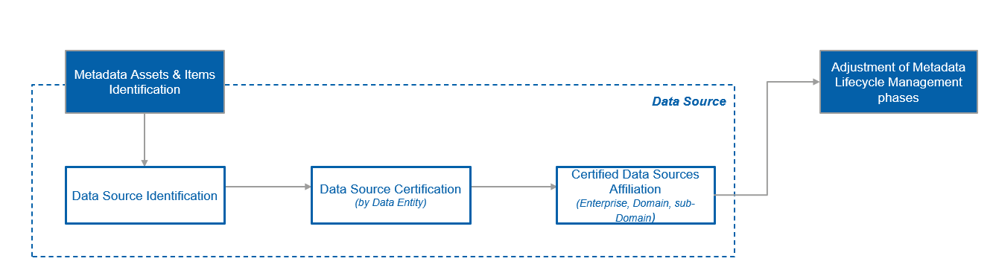
Figure #: Data Source Identification & Certification (Process)
Order | Process Stage Name | Process Stage Description | Roles & Responsibilities
1 | Data Source Identification
2 | Data Source Certification
3 | Certified Data Source Affiliation

Documenting data sources is a critically important practice within data-driven organizations. It involves recording and maintaining comprehensive information about the origins, characteristics, and of internal and external data sources and data entities they supply. The benefits of having data sources documented include:
- Data traceability and transparency: Documentation allows stakeholders working with the data to understand where it comes from, how it was collected, and how it has been processed or transformed. This traceability fosters transparency, builds trust, and enables data consumers to verify the data's integrity and quality. Moreover, data duplication cases become transparent and easily identifiable.
- Data governance and management: Documenting data sources is an integral part of data governance practices. It helps establish clear ownership, responsibility, and accountability for the data, making data management more efficient.
- Risk management: By knowing the sources of data, organizations can assess the risks associated with using specific datasets. It helps in identifying potential vulnerabilities or limitations that might affect decision-making.
- Data integration and interoperability: In data integration activities, understanding data sources is crucial for mapping and transforming data to ensure interoperability between different systems.
- Collaboration and knowledge sharing: Effective documentation promotes collaboration among team members by providing them with the necessary context and insights into the data origins.
The following template helps documenting key data source attributes in a structured way.

Attribute | Description
Identifier | A code unique throughout the whole organization.
Name | A word or a combination of words by which the data source is designated, called, or known by.
Description | A clear and concise overview of the data source providing a brief description of the data source’s purpose.
Is Deprecated | Indicates whether the data source is obsolete, and thus shall be retired (or substituted) soon. In case of substitution, a link to the substituting data source’s documentation should be provided.
Business Owner | A business owner authorized to make decisions regarding the data source’s lifecycle.
Provisioning Points | Business descriptions of the data source endpoints that actually supply (exposed) data assets.
  Attribute | Description
  Identifier | A unique code throughout the whole organization.
  Name | A word or a combination of words by which the provisioning point is designated, called, or known by.
  Description | A brief description of a purpose of the provisioning point.
  Is Authorized | An indication of whether the provisioning point is certified for the data it supplies.
  Related Entities | A list of data entities the provisioning point supplies data sets about.
  Technical Specification | A link to the API documentation.
  Data Restrictions and Limitations | Document any restrictions or limitations on using the data (such as licensing restrictions or confidentiality agreements) supplied by this provisioning point.  Also, any known issues or constraints in the data delivery should be provided by this section.
Authority Tracker | An indication of whether the data source is designated as an authoritative or trusted (certified) for the data entities it operated over.
  Attribute | Value
  Entity Identifier | An entity’s code unique throughout the whole organization.
  Entity Name | A word or a combination of words by which the entity is designated, called, or known by.
  Data Source Authority Type | - Authoritative  - Trusted  - Non-certified
  Data Quality Indicator | The result of the data source certification process for data quality (see section 2.1.1. Data Source Certification Process, Step 5 for more details)  - High  - Medium  - Low
Data Collection Methodology | Describes the methods used to collect a raw data (e.g., surveys, ingestion from other data sources, manual entry, etc.).
Data Processing Approach | Describes a high-level strategy of data preparation for creating the corresponding data products.
Data Usage Terms | A link to a corresponding Data Sharing Agreement.

Data Dictionary Guidelines
      - Data Dictionary Definition and Overview
A Data Dictionary is a structured technical repository or database that contains detailed information about the data elements (fields) used within a database. It serves as a comprehensive reference guide that describes the data's structure, format, semantics, and relationships within the system.
The primary purpose of a data dictionary is to provide a common understanding of the data used in an organization, ensuring consistency and accuracy in data management and usage. It acts as a central source of metadata and helps stakeholders, such as database administrators, developers, data analysts, and business users to understand the data's meaning and usage.
An attribute-level data dictionary and a dataset-level data dictionary are two types of data dictionaries used in data management to document and describe data assets. Here's the difference between them:
Attribute-Level Data Dictionary:
- Attribute-level data dictionary focuses on providing detailed information about individual data attributes or fields within a dataset or database.
- It includes metadata specific to each attribute, such as its name, data type, description, length, format, constraints, and permissible values.
- This type of data dictionary is valuable for data architects, database administrators, and developers who need a granular understanding of each data asset within the dataset or database.
Dataset-Level Data Dictionary:
- Dataset-level data dictionary provides a more comprehensive overview of an entire dataset or database table.
- It includes metadata that describes the dataset as a whole, such as the dataset name, purpose, source, creation date, version, and overall description.
- Additionally, it may include information about the relationships between datasets and the context in which the dataset is used.
- This type of data dictionary is more useful for data users, analysts, and business stakeholders who want to understand the dataset's overall characteristics and relevance.
In summary, the attribute-level data dictionary is more focused on providing detailed information about individual data attributes, while the dataset-level data dictionary provides a broader overview of the entire dataset or database table. Both types of data dictionaries are essential for effective data management, documentation, and understanding of data assets within an organization.

Key Attributes to be Captured
Typically, a data dictionary on dataset-level includes the following information for each data asset:
Attribute | Description | Source of Information
Dataset Name | The name or identifier of the dataset | ServiceNow
Dataset Description | A detailed description of what the data asset represents and its purpose | Manual
Dataset Format | The format in which the data is stored, such as CSV, JSON, XML, database table, etc. | ServiceNow
Status | Data status refers to the condition or state of a dataset at a particular time. It describes the quality, accuracy, completeness, and other characteristics that affect data usability. Common indicators include "valid," "invalid," "in progress," and "historical." Understanding data status is crucial for data users to make informed decisions and ensure reliable data-driven insights. | ServiceNow
Data Domain | A Data Domain that is accountable for a concept relevance, consistency, and quality. If the concept refers to a global business abstraction being reused extensively by many Data Domains (and thus no specific Owning Data Domain could be nominated), ‘Enterprise’ Data Domain should be assigned. | Manual
Data Subdomain | Related subdomain of the domain | Manual
Primary Business Owner | A person who is authorized to make decisions about any aspect of a concept’s lifecycle. | ServiceNow

Data dictionary on attribute-level includes the following information for each data asset:
Attribute | Description | Source of Information
Data Attribute Name | The name or label of the data field or attribute. | ServiceNow
ID | Unique ID of the attribute | ServiceNow
Description | A detailed description of what the data asset represents and its purpose | Manual
Type | The data type of the data set (e.g., integer, string, date) | ServiceNow
Format | The format or pattern in which the data is stored (e.g., date format, numeric format) | ServiceNow
Constraints | Any rules or restrictions applied to the data asset (e.g., maximum length, allowed values) | ServiceNow
Status | Data status refers to the condition or state of a dataset at a particular time. It describes the quality, accuracy, completeness, and other characteristics that affect data usability. Common indicators include "valid," "invalid," "in progress," and "historical." Understanding data status is crucial for data users to make informed decisions and ensure reliable data-driven insights. | ServiceNow

      - Data Dictionary Guiding Principles
      - Data Dictionary Benefits
      - Data Dictionary Composition

Data Asset
A data asset refers to any piece of data that holds significance for Novartis operations, decision-making processes, and overall business performance. Data Asset consists of one of many Data Entities.
Data Asset Types
There are two types of certified data assets:
- Authorized
- Trusted.
Authorized data comes from an authoritative data source via an authorized provisioning point, and that has passed a consumer data certification process. It is the most current and accurate data, which has been vetted according to governance rules and policies and can be verified and signed off by data stewards.
The term of a trusted data refers to the situation where a data asset has passed a certification process, while be provided by a data source other than the authoritative one. This is often the case of data aggregation for multiple sources of certified data. The data is called “trusted” because:
- There is a formal governance process for aggregating the data from trusted or authoritative sources.
- Required business and technical metadata is provided.
- Data assets are formatted into a standardized form and could be traced back to the originating data sources.

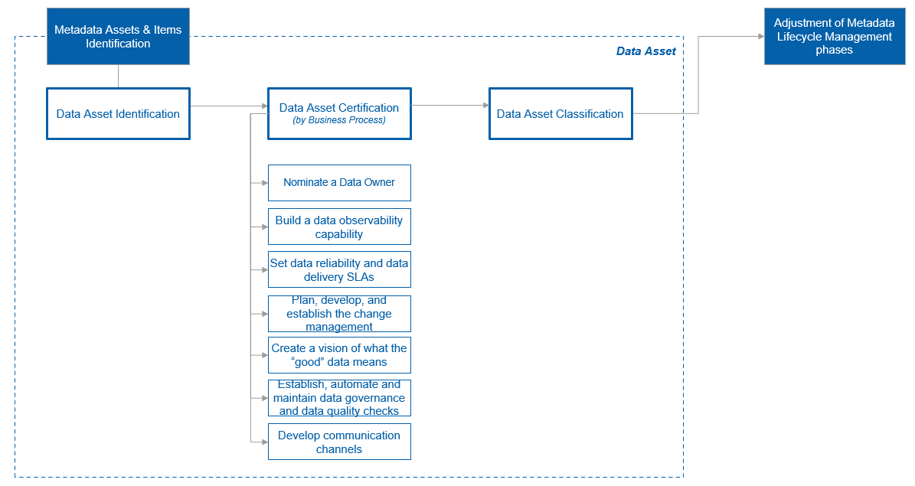
Figure #: Data Asset Identification, Certification & Classification (Process)
Data Asset Certification
Data needs oversight, governance, and management to stay trustworthy, financially rational, and fit-for-business-purpose. Data certification is a process by which datasets are approved for being used across the organization after having met specified requirements upon service-level agreements, compliance to various policies and standards, data quality, data observability, ownership, change, issue resolution, and communication. This is how a dataset becomes a data asset for Novartis.
Even though a data source is certified and designated as an authoritative, it always makes sense to perform a separate data certification at a consumer side due to following reasons:
- Usability and fit-for-purpose: While a data source might be certified as authoritative, the same data might have varying levels of usefulness depending on the intended use case or analytical goal. A data asset certification process can assess whether the data asset meets the requirements of a particular use case, taking into consideration factors like timeliness, granularity, and alignment with specific business objectives.
- Change management: Data sources and their data asset schemas can change over time due to updates or modifications. A data asset certification process can help detect and manage these changes with validating the overall impact of the change. It ensures that any modifications made to the data source, or its structure are accounted for and properly handled in the context of the data asset usage.
- Metadata and documentation: A data asset certification process emphasizes the importance of metadata collection and documentation for each asset. This enhances the discoverability and understanding of data assets, making it easier for data users to find and use the right data for their tasks.
Thus, due to the reasons described, while a data source certification process is essential for ensuring the quality and reliability of supplied data assets, an additional data asset certification process provides a more comprehensive approach to certifying data that is being consumed by certain use cases (after ingestion and before process) or has undergone transformations, aggregations, and contextualization (after processing is completed).

Data Asset Certification Process:
Order | Process Stage Name | Process Stage Description | Roles & Responsibilities
1 | Data Owner Nomination | Each certified data asset should have a responsible party to manage its lifecycle from ingestion to consumption. There are several criteria which can be used to identify an appropriate owner for the data asset:  - Active data usage: Prioritize an individual who actively uses or relies on the data asset in their daily tasks, ensuring practical knowledge of its value and context.  - Business knowledge: Opt for someone who comprehends a business context of the data asset, enabling effective decision-making.  - Accountability: Select an individual who is willing to take responsibility for data quality, security, privacy, and compliance from the experience, authority, and capacity perspectives.  - Business process alignment: Align data ownership with business processes (for key/critical data entities and their corresponding data assets). The owner should be a key stakeholder in the process that generates, uses, or relies on the data asset.  - Business concept alignment: Align data ownership with (business glossary) business concepts involved – the owner of the adjacent business concepts may become the owner of the data asset (typically applied when a data asset has only a single business concept associated).  There could be cases, however, that even after considering all the listed criteria, there are still several stakeholders who compete for owning the data asset. There are typically two approaches to resolve the situation:  - if the data asset has a single data entity associated, considering the data entity’s affiliation level, to engage a corresponding Governing Body to make the decision about ownership assignment.  - Split the data asset into several chucks and assign the individuals to own the chucks basing on the criteria listed above.
2 | Build a data observability capability | Data observability is the ability to fully understand the health of the data within its context. Not only it is needed to collect insights into the current performance to set a baseline, but it is also required to establish an end-to-end approach for proactive incident discovery, alerting and triaging.
3 | Set data reliability and data delivery SLAs | SLA need to be specific, measurable, and achievable, and should include responsibilities, and operations in the cases of meeting and violating the SLA, e.g., “Team A will ensure the data in table X will be refreshed every day by 7:00 am. Within 2 hours of an anomaly alert, the team will verify, communicate to affected parties, and begin a root cause analysis of the issue. Within one business day a corresponding ticket will be created, and a reviewing team shall be nominated and be kept updated on the progress made towards resolution”.
4 | Plan, develop, and establish the change management and incident management processes | Operational support
5 | Create a vision of what the “good” data means | This step implies communicating with business stakeholders the “who, what, when, where and why,” aspects of data provisioning and usage. This is where the topics of data governance and data quality arise.
6 | Establish, automate and maintain data governance and data quality checks | Establish, automate and maintain data governance and data quality checks for every ingestion or change occasion happening with the data asset, based on the defined profile of the “good” data.
7 | Develop communication channels | Define and socialize communication channels to keep the target audience posted about the latest updates, upcoming changes, or identified issues about the data under consideration.

Data Asset Classification Process
Data classification refers to the process of categorizing and labeling data based on its sensitivity, importance, and usage within an organization. The process is mandatory for all data managed in the context of all data domain and primary goals are the following:
- Identify sensitive or confidential data that requires enhanced security measures. By categorizing the data, the appropriate security controls can be applied to protect it from unauthorized access. This influences the architectural design of the information systems.
- Make sure that data is managed following compliance with regulations, standards, and internal data management policies.
It is important to differentiate Information System Classification, Data Asset Classification within Information System and Assets Attribute Classification. They are related, but the target for the classification is different:
Data Classification Level | Description
Information System Classification | This clarification can be used to classify any applications, data platforms, websites, SaaS applications, and other systems where any Novartis data are managed. The details of this classification and all possible tags can be found on https://go/dataclassification
Data Assets Classification within Information System | This classification is applied to data assets managed in data domains. This classification schema contains subset of classification tags applied to Information systems and includes the following tags:  - Data Privacy  - Data Confidentiality  - Data Integrity  - Published from GxP Validated system  By default, the values for tags above Data Asset Classification inherited from Information System Classification Level. The list of Tags also can be extended depending on data domain needs.
Assets Attribute Classification | This classification level is optional. This applied to attributes with data assets. By default, the classification is inherited from Data Asset Level. However, the values for Data Privacy, Data Confidentiality and Data Integrity can be redefined for attributes. This lets us identify exact attributes which require additional attention (implement data masking and etc.). Also, additional custom classification Tags can be used on attribute level depending on data domain needs.

General Classification Rules:
- By default, all values of classification Tags inherited from Higher to Lower level (from Information System Classification to Data Assets Classification and from Data Assets Classification to Assets Attribute Classification)
The values on Lower level can be redefined, but they should not conflict with Higher classification level. For example, we cannot specify Data Confidentiality as Business Use Only for a whole Data Asset, but set Restricted only for some attributes. If there is at least one attribute defined as Restricted, then the whole Data Asset should be defined as Restricted as well. The opposite situation is possible (we may have the whole Data Asset defined as Restricted, but some attributes may have Business Use Only classification)
The values of classification Tags for lower classification level cannot be stricter than defined higher level. If such scenario appears then this indicates wrong classification for higher level. The opposite scenario is possible.
This principle demonstrated in the examples below:
For Veeva CRM system Data Privacy categorization is defined as “Personal Information – High Risk” because datasets related to HCPs personal info are stored there. However, not all data assets managed in Veeva CRM System contain Personal Information data, for example, Marketing Products data asset stored in Veeva CRM will be categorized as “No personal Data” as this data assets do not contain any personal information.
Only details of mandatory classification schema are included in this guideline, but within data domains additional clarifications tags can be created depending on data management needs.
For adding new classification Tags the following steps are required:
# | Step Description | Actors (Roles)
1 | Initiation of adding of new tag, specifying the business reason of the new tag is required, formalization of tag usage requirements | EDO, Data Steward
2 | Analyzing requirements for a new tag, alignment with existing global metadata to check if the required tag is already available.  Communicate with the requestor if there are any doubts about the needs of new classification tag | Data Architect
3 | Including the tag into classification framework used in the data domain (confluence page or document). If required - creating request for the team responsible for data cataloging solution to add new tag | Data Architect
4 | Check availability of new tag in the Data Catalog and start using this to address new data classification requirements | Data Steward

See below description of real scenario where custom tags can be created.
Example:
Typical additional data classification that can be implemented in the context of data domain is data usage classification. For example, in Finance data domain there could be data assets which contain regional data (combined from few countries) and country data (related to one country). Both data assets can be categorized as Restricted from confidentiality point of view. But Regional data can be used only by audience from the respective regions, so for USAGE tag values like “COUNRY USAGE” and “REGIONAL USAGE” can be applied. This allows us to create a foundation for the security model implemented in the context of the data domain.
Mandatory Data Classification Tags

Data Privacy
Data privacy is concerned with the appropriate handling, use, and disclosure of personal information in accordance with privacy laws, regulations, and individual rights. It involves protecting individuals' personal data and ensuring that it is collected, processed, and stored in a secure and responsible manner.
Personal Information (sometimes called Personal Data) is any information related to a real person, such as a patient, a healthcare provider, a Novartis associate, and other individuals. It may also include information about a browser or device used by one of these individuals. Please see below the data privacy levels used in Novartis (see full definitions and examples here - https://go/dataprivacy ):
Tag Value | Definition
No Personal Data | NA
Personal Information – Low Risk | This is the personal information used in normal course of Novartis business (‘Need to know’ principle applies), an inappropriate use of which would cause minor consequences to the rights and freedom of data subjects and/or to the Novartis Group of companies. The impact of such use/disclosure corresponds with a Minor or Insignificant impact level
Personal Information – Medium Risk | This is the personal information used in normal course of Novartis business (‘Need to know’ principle applies), an inappropriate use of which would cause moderate consequences to the rights and freedom of data subjects and/or to the Novartis Group of companies. The impact of such use/disclosure corresponds with a Moderate impact level
Personal Information – High Risk | This is very sensitive personal information, an inappropriate use of which would cause serious or significant consequences to the rights and freedom of data subjects and/or to the Novartis Group of companies. The impact of such use/disclosure corresponds with a Major or Severe impact level

Data Confidentiality
Data confidentiality refers to the protection of sensitive or confidential information from unauthorized access, disclosure, or alteration. It focuses on ensuring that only authorized individuals or entities have access to the data. Confidential data may be financial data, trade secrets, or any other information that, if accessed by unauthorized parties, could cause harm, breaches, or privacy violations. Please see below the confidentiality level used in Novartis (see full info for risks impact here - Enterprise Risk Management Guideline (novartis.net):
Tag Value | Definition
Public | Information is approved by Novartis management to be made available to the public.
Business Use Only | Information used in the course of normal business, the loss or disclosure of which could cause minor damage to Novartis.
Restricted | Sensitive information, the loss or disclosure of which could cause moderate damage to Novartis.
Strictly Confidential | Highly sensitive information, the loss or disclosure of which could cause major or severe damage to Novartis

Data Integrity
It ensures that the data is correct, complete, and maintains its intended meaning and quality throughout its lifecycle. This means that information cannot be modified in an unauthorized or undetected manner. The following categories of Data Integrity should be used (see full info for risks impact here - Enterprise Risk Management Guideline (novartis.net:
Tag Value | Definition
Standard | Information for which accidental or malicious alteration could cause moderate damage to Novartis.
Vital | Information for which accidental or malicious alteration could cause major or severe damage to Novartis.

Publish from GxP Validated Systems
GxP (Good x Practice) classification is used to label data assets as GxP if processes used within Information Systems where these data assets stored comply with the regulations. If some data assets are classified as Non-GxP then they should not be shared with GxP classified Information Systems or at least owners of these system should be notified about Non-GxP data assets planned for the usage. See details of this classification in the table below:
Tag Value | Definition
GxP | Both criteria from the list below should be True  - The data asset stored in the Information System classified as GxP – Low, GxP- Medium or GxP – High  - If data asset is created as combination of data assets from sourced from multiple Information Systems, then all these systems must be classified as GxP – Low, GxP- Medium or GxP – High
Non-GxP | At least one criteria from the list below should be True  - The data asset stored in Non-GxP Information System  - If data asset is created as combination of data assets from sourced from multiple Information Systems, then at least one among these systems should be Non-GxP

Data Classification Initiation
The data classification should be initiated by Data Steward of a data domain which is accountable for the whole process. The data classification process for Data Assets owned by Dat Domain can be triggered in the following scenarios:
- Any Information system gets associated to the data domain (existing system or a new one). It is required to classify data assets stored there if there are plans to create new integrations for the data managed in these Information Systems (for example, copying any data from one system to data platform / another system)
- Any data assets are created within data domain as combination of other data assets. The new (produced) data assets are not necessary will follow the same classification as the source data assets.)
Example for scenario 2) is presented below. Consider the following two data assets:
Customers (HCP)
Attribute | Example of Value
Customer ID | XXXYYYT55312HNT
Name | John Smith
Address | 1630 Revello Drive  Sunnydale, CA 12345
Primary Affiliated Hospital | Aurora Las Encinas Hospital
License Number | 64364364674

Customer Prescriptions
Attribute | Example of Value
Month | 2023-01
Customer ID | XXXYYYT55312HNT
Product | Cosentyx
Number of Prescriptions | 10
Both data assets should be categorized as Restricted because this includes HCP personal data and prescriptions on HCP level are sensitive for Novartis.
The new data assets created based on these two data assets as combination of both data assets (aggregated on country level)
Attribute | Example of Value
Month | 2023-01
Country | US
Product | Cosentyx
Number of Prescriptions | 1000
This data asset does not contain any HCPs information (this is aggregated data on country level) and this type of dataset can be found in healthcare data providers (like IQVIA), so the confidential level can be reduced to Business Use Only.

Data Asset Certification Process:
Order | Process Stage Name | Process Stage Description | Roles & Responsibilities

      - Data Dictionary: Process
Data Dictionary: Process <component definition -> additional stages dedicated to certification/ classification/ categorization -> component metadata definition-> populate described structure of metadata with component values>
Order | Process Stage Name | Process Stage Description | Roles & Responsibilities | Application Name

Technology Assets Guidelines
      - Technology Assets Definition and Overview
      - Technology Assets Guiding Principles
      - Technology Assets Benefits
      - Technology Assets Composition

Data Physical Repositories
Applications / Physical repositories: Physical repositories of data refer to the physical storage locations where data assets are stored within an organization. These repositories can include various types of data storage infrastructure, such as databases, file systems, data warehouses, spreadsheets, streaming data, data lakes, and other structured or unstructured data storage systems.
Metadata: Metadata for physical repositories refers to descriptive information that provides context and details about the contents, organization, and management of physical data stored in repositories or archives. It includes information such as titles, owners, physical locations, and descriptive notes, aiding in the discovery, identification, and retrieval of specific items.
Benefits of capturing physical repositories metadata
In the context of data architecture, capturing metadata for physical repositories offers several benefits:
- Integration with Data Repositories: By capturing metadata, organization can integrate physical repositories with databases, creating a comprehensive and unified view of the organization's data assets.
- Data Mapping and Lineage: Metadata helps in mapping physical data to corresponding information. It is also used while establishing data lineage to audit trail of data flow across different repositories.
- Data Governance: Metadata supports data governance efforts by providing insights into the origin, quality, and usage of physical data assets, enabling better data management and compliance with data policies.
- Data Cataloging: Metadata serves as a catalog for physical data assets, enabling organization to categorize them in a way that aligns with the organization's overall data architecture.

Metadata for physical repositories helps organize and provide valuable information about the physical assets stored within a repository. Here is the main steps to capture metadata for physical repositories:
Order | Process Stage Name | Process Stage Description | Roles & Responsibilities
1 | Creating inventory of physical repositories | All data assets and related physical repositories within the organization should be listed to create an inclusive inventory | Domain Architects
2 | Identifying key attributes | Attributes that are going to be captured need to be selected to create a comprehensive metadata list. Following topics should be covered according to best practices:  - Descriptive definitions and unique identifiers  - Authoritative domains (owner, data domain, sub domain) to identify responsible people  - Data controls including confidentiality, integrity, availability and data privacy  - Retention policies  - Location of the repositories and information of which country’s data being used to ensure compliance | Data Architects
3 | Capturing metadata | The selected list of metadata should be captured properly. In case metadata is already captured in previous processes in order not to create duplicate values, it is better to automate the capturing process. | Domain Architects and Data Stewards
4 | Documentation and regular review | The capturing process needs to be documented and reviewed regularly to ensure quality. | Domain Architects and Data Stewards

By following this guideline, you can establish a comprehensive metadata framework for physical repositories, enabling effective management, organization, and retrieval of the assets stored within.
Key attributes to be captured as physical repositories metadata
Information can be directly retrieved from ServiceNow if the application is listed in HLCCD and attribute is already collected properly. This should be done not just to increase automation but also to decrease duplicate information storage. If application or information is not listed in HLCCD, manual data collection is required.
Field No | Field to Capture | Mandatory Field (Y/N) | Description of the Field | Source of the Information | Further Readings
1 | Application ID | Yes | The Application ID is the unique ID assigned to each Novartis application. It is generated by the ServiceNow APM module as part of application onboarding. The link between HLCCDs and Applications enables to transfer of compliance information and effective application lifecycle management.  Note :- For an external application, if HLCCD does not exist in Service Now, this attribute must be maintained manually. | ServiceNow | Article - OneNovartisServices (service-now.com)
2 | Application Name/Physical Repository Name | Yes | The application name given to identify the application along with the application ID. The name of the application should not be equal to the name of the software product, but specific to this implementation (e.g., use an acronym)  Note :- For an external application, if HLCCD does not exist in Service Now, this attribute must be maintained manually. | ServiceNow
3 | Application Description | Yes | General description of the application, its value to the business, and additional comments, what functionality the application provides (e.g., which business process / which steps in a business process it supports) and what value the application adds to the business / why it is required. Add comments if necessary. | Manual
4 | Active Flag | Yes | States whether application is still active and being used or deactivated  Note :- For an external application, if HLCCD does not exist in Service Now, this attribute must be maintained manually. | ServiceNow
5 | Application Owner | Yes | Owner of the application with contact details  Note :- For an external application, if HLCCD does not exist in Service Now, this attribute must be maintained manually. | ServiceNow
6 | Data Domain | Yes | Data domain that is responsible with the application. Selections should be done via drop down menu | Manual
7 | Subdomain | Yes | Data subdomain that is responsible with the application. Selections should be done via drop down menu | Manual
8 | Business Capabilities | Yes | This field shows the business capabilities. Selections should be done via drop down menu which enables multiple and standardized selections. | Manual
9 | Business Owner | Yes | Owner of the application from business side with contact details  Note :- For an external application, if HLCCD does not exist in Service Now, this attribute must be maintained manually. | ServiceNow
10 | Confidentiality | Yes | Identifying the Confidentiality level of information assets is essential for effective risk management, access controls, data handling, compliance, incident response, and supplier management. Confidentiality is a criterion for determining the application Risk Tier and applicable controls, reducing the risk of unauthorized access, disclosure, or compromise. Confidentiality levels can be . For values, please go to go/Classify  Note :- For an external application, if HLCCD does not exist in Service Now, this attribute must be maintained manually. | ServiceNow | Information Classification (novartis.net)
11 | Integrity | Yes | Identifying the Integrity level of an application is important for data accuracy, trust, compliance, prevention of unauthorized modifications, detection of data tampering, audibility, and accountability. Integrity is a criterion for the application Risk Tier, and it ensures applicable controls are in place to maintain the reliability and trustworthiness of the information processed by the application. For values, please go to go/Classify  Note : For an external application, if HLCCD does not exist in Service Now, this attribute must be maintained manually. | ServiceNow | Information Classification (novartis.net)
12 | Availability | No | Identifying the Availability level is crucial for ensuring service continuity, maintaining efficient business operations, aligning with SLAs, enabling effective incident response and recovery, and managing availability-related risks. Availability is a criterion for the application risk tier, and it ensures applicable controls are in place to allow uninterrupted access to critical services and information.  Availability levels can be:  Low for applications that are not linked in any way to a Key Business Process.  Medium for applications that support to the operation of Key Business Processes.  High for applications that are mandatory to operate Key Business Processes.  Note :- For an external application, if HLCCD does not exist in Service Now, this attribute must be maintained manually. | ServiceNow | Onboarding - Home (novartis.net)
13 | Data Privacy | Yes | Data Privacy is a criterion for determining the application Risk Tier and applicable controls to comply with privacy regulations, protect sensitive information, facilitate data sharing, and enable effective incident response. For Data Privacy values, refere to go/classify  Note :- For an external application, if HLCCD does not exist in Service Now, this attribute must be maintained manually. | ServiceNow | Group Data Privacy - ePA_Request (novartis.net)
14 | Countries where data is stored | No | Knowing where data is stored is essential for legal compliance, data security, efficient data management, data sovereignty, and business continuity. It enables Novartis to make informed decisions about data handling, implement appropriate security measures, and ensure compliance with relevant laws and regulations.  Note :- For an external application, if HLCCD does not exist in Service Now, this attribute must be maintained manually. | ServiceNow | CSL Home Page - China Cyber Security Law (service-now.com)
15 | Enterprise Level  Application Flag | No | This flag states whether the application is on Enterprise level or country level. The following question needs to be answered in this field. “Does the application use the data of all corresponding countries as a centralized enterprise application?”  Yes when it is enterprise level which is used globally to store the information of all corresponding countries  No when the application is specific (localized) to one country or group of countries | Manual
16 | Which country’s data is being used | No | This section will be active if “Attribute 16: Does application use all countries’ data on enterprise level” is selected as “No”. If the application is not on enterprise level, knowing the origin of data will enable to take necessary precautions to comply country specific local regulations. | Manual
17 | Retention policies | Yes | The record types define the retention and disposition policies. | Manual | Novartis Global Records Retention Schedule (zasiocloud.com)
18 | External (3rd party) Data Flag | Yes | Yes / No flag which is stating whether application stores or uses any kind of 3rd party data. | Manual

Operational Assets
Operational Assets refers to Operational Metadata that provides information about the operational aspects of data processing and system activities within an organization's information systems. It captures details about the execution, performance, and monitoring of various processes, transactions, and interactions that occur within the IT environment. Operational metadata serves as a behind-the-scenes record of system behaviors, helping organizations manage, optimize, troubleshoot, and ensure the reliability of their systems and data processes.
Key aspects of operational metadata include:
- Data Processing Flows: Operational metadata traces the flow of data through different stages of processing, from ingestion to storage, transformation, and consumption.
- Execution Logs: It includes logs and records detailing the execution of data processing tasks, software applications, and system components.
- System Performance: Operational metadata captures performance metrics, resource utilization, response times, and other indicators of system health.
- Error Tracking: Operational metadata records errors, exceptions, and anomalies that occur during data processing, aiding in issue resolution.
- Job Scheduling: Details about scheduled tasks, automation processes, and their execution times are often part of operational metadata.
- Resource Management: Operational metadata may cover the allocation and utilization of hardware, software resources, and network connections.
- Data Lifecycle Management: It records the movement of data through its lifecycle stages, such as creation, modification, archiving, and deletion.
- System Events: Operational metadata documents system events such as system startups, shutdowns, backups, and updates.
- User Activity: In some cases, operational metadata includes records of user activities, login/logout events, and access permissions.
- Security Auditing: It tracks security-related events, such as authentication, authorization, and access attempts, aiding in security audits.

Operational Metadata is valuable for IT management, system optimization, troubleshooting, compliance monitoring, and performance analysis. It helps IT teams gain insights into the behavior of their systems, enabling them to detect issues, identify bottlenecks, and enhance the overall efficiency and reliability of data processing and system operations.
Attribute | Description
Process Name/ID | Identifier or name of the data processing or system activity.
Start Time/End Time | Timestamps indicating when the process started and ended
Execution Duration | Time taken for the process to complete
Status/Result | Outcome of the process (success, failure, in progress, etc.).
Resource Utilization | Information about CPU, memory, disk, and network resources used during the process.
Data Volume | Amount of data processed, transferred, or generated by the process
History of Job Scheduling | Scheduling information, including start times and recurrence patterns
Error Logs | Details of errors, exceptions, or issues encountered during execution.
Backup and Restore | Details of backup and restoration processes
Authentication and Authorization | Information about user authentication and authorization activities.
Technical Users/Operators | Identity of the users or operators initiating or overseeing the process.

These attributes collectively provide a comprehensive view of how data is processed, transferred, and managed within an organization's systems, allowing for effective monitoring, troubleshooting, and optimization of data processing activities.

      - Technology Assets: Process
Technology Assets: Process <component definition -> additional stages dedicated to certification/ classification/ categorization -> component metadata definition-> populate described structure of metadata with component values>
< If it’s required>
Order | Process Stage Name | Process Stage Description | Roles & Responsibilities | Application Name

Linkage between Business Glossary and Data Dictionary
Business glossary metadata can come from a variety of sources, both technical and non-technical. Thus, it is important to differentiate between a business glossary and a data dictionary to clearly understand where each type of metadata should go.
 | Business Glossary | Data Dictionary
Focus | A business glossary is focused on business meaning and is created for business stakeholders mainly. | A data dictionary is focused on the technical specifications of data assets contained within it.
Structure | A business glossary contains structured business concepts, measures, guidelines and rules. | A data dictionary usually consists of a list of datasets and their structures (e.g., datasets, tables, columns).
Aim | The aim of a business glossary is to provide a common vocabulary and understanding of business concepts and measures. | The goal of a data dictionary is to clearly understand a technological aspect of a data asset flow.

In the context of Enterprise Data Management program, the relationship between a business glossary and a data dictionary is crucial for ensuring effective communication, understanding, and alignment between business stakeholders and technical teams.
While a business glossary serves as a reference guide that provides clear and consistent definitions for key business concepts, ensuring that all stakeholders have a shared understanding of their meanings, a data dictionary is a technical reference that provides detailed information about organization's data assets stored in physical data repositories.
The linkage between a business glossary and a data dictionary involves aligning business concepts with their corresponding technical representations -- datasets. This connection ensures that both business and technical stakeholders have a shared understanding of the data being used, enhancing collaboration, data quality, and overall decision-making.
Step-by-step linkage process:
- Identify a critical data entity. This step includes assignment of appropriate classes, categories, and (primary and secondary) owners to the data entity.
- Document the data entity (as a business concept) in a business glossary.
- Identify essential data entity attributes that indicate how the data entity used within the context of key business processes. Create datasets which contain records of data entity instances described against the selected attributes. These datasets will be comprehensively documented in a data dictionary.
- Link the business concept in the business glossary to corresponding data assets in the data dictionary using the “Associated Data Assets” optional attribute, and vise versa, define the linkage to the business concept by creating a link to it for every corresponding dataset from the data dictionary using the “Associated Business Concepts” attribute.
Maintain consistency -- ensure that any changes or updates to the business glossary are reflected in the data dictionary, and vice versa.

Data Lineage Guidelines
      - Data Lineage Definition and Overview
Data Lineage refers to the end-to-end documentation and visualization of the journey of data as it moves through various systems, processes, and transformations within an organization. It provides a comprehensive and detailed understanding of the origin, movement, and transformations applied to a particular piece of data, from its source to its destination or usage.
In simpler terms, data lineage answers the question of "where did this data come from?" and "how has it been processed or modified along the way?"
There are 2 core types of data lineage. These are Business Lineage and Technical Lineage.
Business lineage and technical lineage are two aspects of data lineage that provide insights into different aspects of data movement and transformation. Here are the key differences between them:
 | Business Lineage | Technical Lineage
Focus | Focuses on how data flows and transforms to serve business processes, decisions, and outcomes. It highlights the business context and impact of data movement. | Focuses on the technical aspects of data movement, detailing the systems, processes, and transformations involved in data processing.
Audience | Primarily targeted at business users, analysts, and stakeholders who need to understand how data supports business processes and decision-making. | Primarily targeted at data engineers, IT teams, and technical stakeholders who need to understand the technical flow and transformations of data.
Granularity | Provides a higher-level view of data movement, emphasizing key business processes and the data's role in those processes. | Offers a more detailed view, showing the specific data transformations, transformations, and technical components involved.
Representation | Often represented using business process diagrams or flowcharts that illustrate how data contributes to business workflows. | Represented using technical diagrams that show the sequence of data transformations, databases, systems, and integration points.
Benefits | Helps align data initiatives with business goals, supports data-driven decision-making, and ensures data supports accurate business outcomes. | Assists in system monitoring, troubleshooting, impact analysis, and ensuring data quality through the technical data flow.
Usage | Used for regulatory compliance, understanding data dependencies, and making business process optimizations. | Used for system maintenance, debugging, performance optimization, and ensuring data integration accuracy.
Example | Demonstrates how customer data flows through different departments to create marketing campaigns. | Illustrates the data transformations that occur as raw sales data is transformed into summarized reports.
Both business lineage and technical lineage play crucial roles in data management, allowing organizations to understand data movement and transformations from both business and technical perspectives, enhancing overall data understanding, governance, and decision-making.

      - Data Lineage Guiding Principles
      - Data Lineage Benefits
      - Data Lineage Composition

Business Lineage

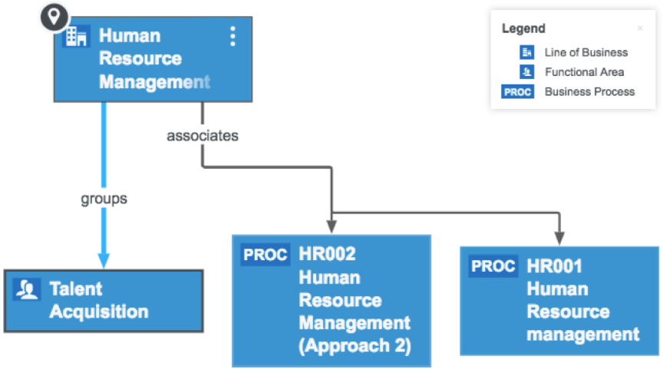
Business Lineage is a critical concept in Enterprise Data Management that refers to the end-to-end understanding and documentation of how data flows, transforms, and is used across business functions and data domains. It aims to provide a clear and comprehensive view of data's journey from its origin through its transformations to its consumption, giving also a view of a business context (categories, business concepts and business processes associated with data assets) and showing information about relations between the entities and systems.

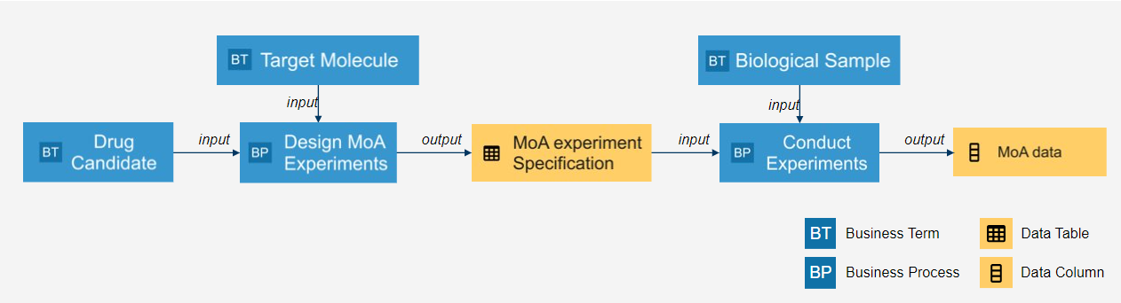
Key components and processes of business lineage
Business lineage is added on top of technology lineage providing business insights into data flows, from source systems, through transformations, to consumption.
- Business context visualization:
  - Business function and data domain structure mapping. Shows selected parts of the organizational structure and relationships between its units based on the data flows established.
  - Business process mapping. Indicates affiliation of data entities to certain business processes.
  - Business concept mapping. Shows association of business concepts to the data assets presented on the lineage diagram.
- Data source description. Identify suppliers on an input data. These can be Novartis business functions or systems, or 3rd parties. Within the suppliers, data provisioning points where the data originates / is being distributed from must be specified, e.g., platforms, services, databases, or applications. This involves marking data sources as authoritative / trusted / non-classified, and corresponding provisioning points as authorized / non-classified, for particular data entities.
- Data transformation summary. On business lineage (comparing to technical lineage) data transformations are typically specified from the conceptual level giving a business summary of technical transformations performed over data entities. Two aspects should be described there:
  - Transformation logic -- conceptual transformations applied to data entities, including cleansing, enrichment, normalization, and calculations.
  - Business rule mapping – a set of business rules that guide and constrain the data transformations.
- Elaboration of relationships. Types and short text descriptions for relations between business components can be shown, thus giving more context about the hierarchies, dependencies, and interactions.
- Data consumption description. Shows scenarios where data is consumed for reporting, analytics, or operational purposes.
- Data governance and compliance aspect mapping. Outlines data governance procedures and processes, together with regulations and standards business components and data flows must adhere to.

Technical Lineage
Technical Lineage involves documenting and visualizing the detailed technical path of data as it moves through an organization's systems, applications, and processes. It emphasizes the specific transformations, integrations, and interactions that occur at a technical level. Technical lineage helps IT teams and data engineers understand data flow, identify bottlenecks, troubleshoot issues, and ensure accurate data integration. It provides insights into the underlying technical components, architecture, and infrastructure involved in data movement, contributing to effective data management, system optimization, and data quality assurance.
Key components of technical data lineage are:
Attribute | Description | Source of Information
Data Source | The starting point of the data lineage, which represents the original source of the data, such as a database, file, application, or external system. | ServiceNow
Data Transformation | Nodes representing data transformations, such as filtering, aggregation, joins, and calculations, that occur as data progresses. | ServiceNow
Data Storage (Destination) | The intermediate and final destinations where the data is stored or consumed, such as databases, data warehouses, or analytical tools | ServiceNow
Type of Connection | The connections and dependencies between different data assets within the lineage, illustrating how they relate to each other | ServiceNow
Data Timestamps | The timestamps or time information associated with the data, showing when it was generated, updated, or processed at each stage of the lineage | ServiceNow
Metadata Platform | Software system that centrally manages and stores metadata related to data assets, processes, and resources within an organization | ServiceNow
Application as Source | Golden source application of the data | Manual
Application as Target | Ultimate target applications that data is going to be used | Manual

      - Data Lineage: Process
Data Lineage: Process <component definition -> additional stages dedicated to certification/ classification/ categorization -> component metadata definition-> populate described structure of metadata with component values>
Order | Process Stage Name | Process Stage Description | Roles & Responsibilities | Application Name

Definitions
Term | Definition
<Only include definitions for
terms included in this document.>

Abbreviations
Abbreviation | Description
EDM | Enterprise Data Management
EA | Enterprise Architecture
DA | Data Architecture
SME | Subject Matter Expert

References and Appendices [Edit or delete as needed]

References
<All references to other documents must be included with the first one being noted by the reference number. References are documents that are referred to in the text of this document>
Reference Number | Document Name

Appendices [delete if not used]
<Appendices are text added to the end of a document, containing additional information.>

Appendix A (Name of appendix)

